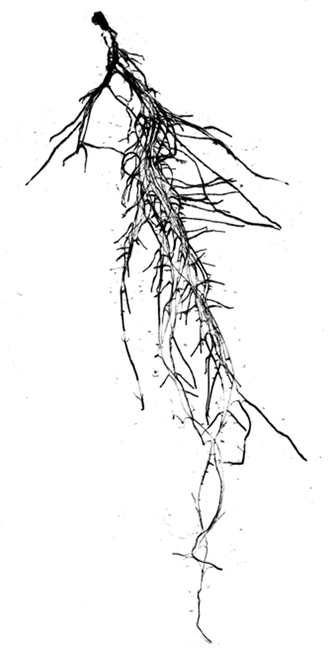Lab. of Plant Physiology and Molecular Genetics, Université libre de Bruxelles, Brussels, BE

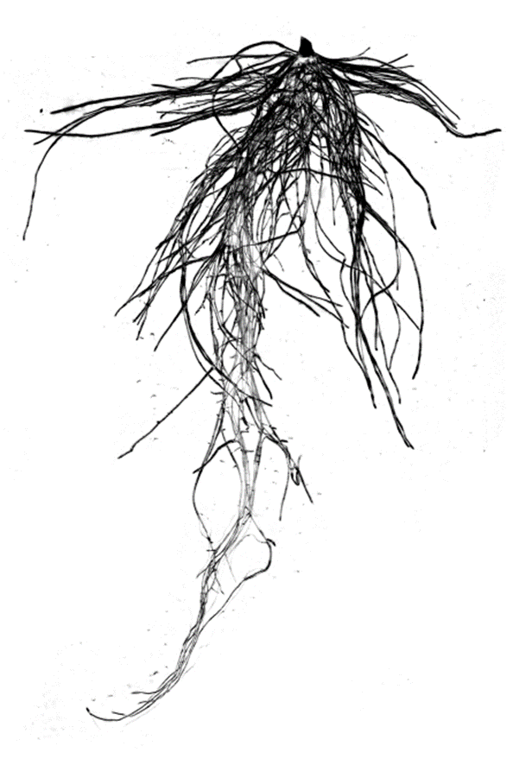

**JOB OFFERS**

**Post-doc position in bioinformatics at ULB: Genes and gene networks analysis related to root morphological response to nitrogen supply in plants**

Mineral nitrogen (N) is the quantitatively most important nutrient in cropping systems. However, a considerable N fraction is lost through runoffs with detrimental consequences for the environment and human health. Increasing the plant N uptake by optimizing the degree of root branching for exploring a larger soil volume in search of the mobile nitrate resource may contribute to limit soil leaching. Oilseed rape (*Brassica napus* L.) is a major oil crop showing whose production highly dependents on N fertilization. The project aims at understanding the genetic control of root system architecture and how it is impacted by N nutrition. A measurable outcome will be to provide genetic markers for selecting new crop genotypes with positive root morphological features.

* **One post-doc fellowship for non-Belgian resident** (3 years) - as early as October 2019

Relevant experience:  *Arabidopsis - Brassica* genomics, QTL mapping (association and linkage), ShoreMap, gene networks

Eligibility: Maximum 6 years after PhD, no more than 24 months residence in Belgium during the three last years

Enthusiastic researchers meeting these criteria (only those with previous experience in bioinformatics will be considered) are kindly invited to contact Christian HERMANS (**chermans@ulb.ac.be**). Include your CV, qualifications and the names of two academic referees whom I can approach prior to appointment. Applications must be received by August 15th 2019.