Call for Abstracts

The NSBM cordially invites you to visit its fall meeting, 2013. During the meeting, the floor will be given to PhD students and post-docs who study protein structure and/or structural bioinformatics or related topics (see a list below).

The title of the meeting will be: "First Euregional Meeting on Structural Bioinformatics and Modeling of Biomolecules in Belgium, Germany and Netherlands"

As guest speakers, Prof. Joost Schymkowitz of the VIB Switch Laboratory, KULeuven, Belgium will give a seminar titled: "Protein aggregation in disease and design" and Dr. Christian Ottman of the Biomedical Technology department, TUe will give a seminar titled: "Small-molecule stabilization of Protein-Protein Interactions".

Abstract Format
Abstracts should be limited to a maximum of 10 lines, with 12-pt font and single-spaced text, giving a short description of the research done.
Please include a title in bold. The name(s) and affiliation(s) of the author(s) should follow the title. The opportunity will be given to present a limited number of posters, though this is not mandatory. If you wish to present a poster, please indicate so.

Abstract Submission
All abstracts, should be submitted electronically in MSWord via e-mail attachment to g.nicolaes@maastrichtuniversity.nl with as subject line “NSBM Fall meeting 2013”.

The deadline for receipt of all abstracts is October 10th 2013. Selected candidates will be notified no later than October 15th 2013.

Presentations will be 20 min, including a 5 min discussion. Starting PhD students are particularly encouraged to present their research.

For questions regarding the abstract or meeting please contact Gerry Nicolaes, +31-(0)43 3881688, g.nicolaes@maastrichtuniversity.nl

Registration
Registration can be made free of charge via e-mail to g.nicolaes@maastrichtuniversity.nl with as subject line “NSBM Fall meeting 2013”. A lunch and coffee/tea breaks will be provided for. In consideration of traveling time, the registration will take place from 10:00-10:30, the program ends at 17:00h. Further details on the specific program and location will be announced.

Should a lack of funding be a hurdle for visiting the NSBM Spring Meeting, please contact prof. Gert Vriend at vriend@cmbi.ru.nl so that an arrangement can be made.

Topics for presentations may include, but are not limited to:
• Computational Biology and Bioinformatics
• Computer-aided drug design
• Drug design and drug discovery
• Grid computing
• Homology modelling
• Molecular and supramolecular dynamics
• Molecular modeling and simulation
• Mutational analysis
• Protein crystallography
• Protein NMR
• Protein structure analysis
• Protein structure prediction
• Protein-protein interactions
• Protein-small molecules interaction
• Protein software design
• Proteomics
• Structural bioinformatics
• Structure-function analysis
• Text mining & information extraction
• Virtual screening

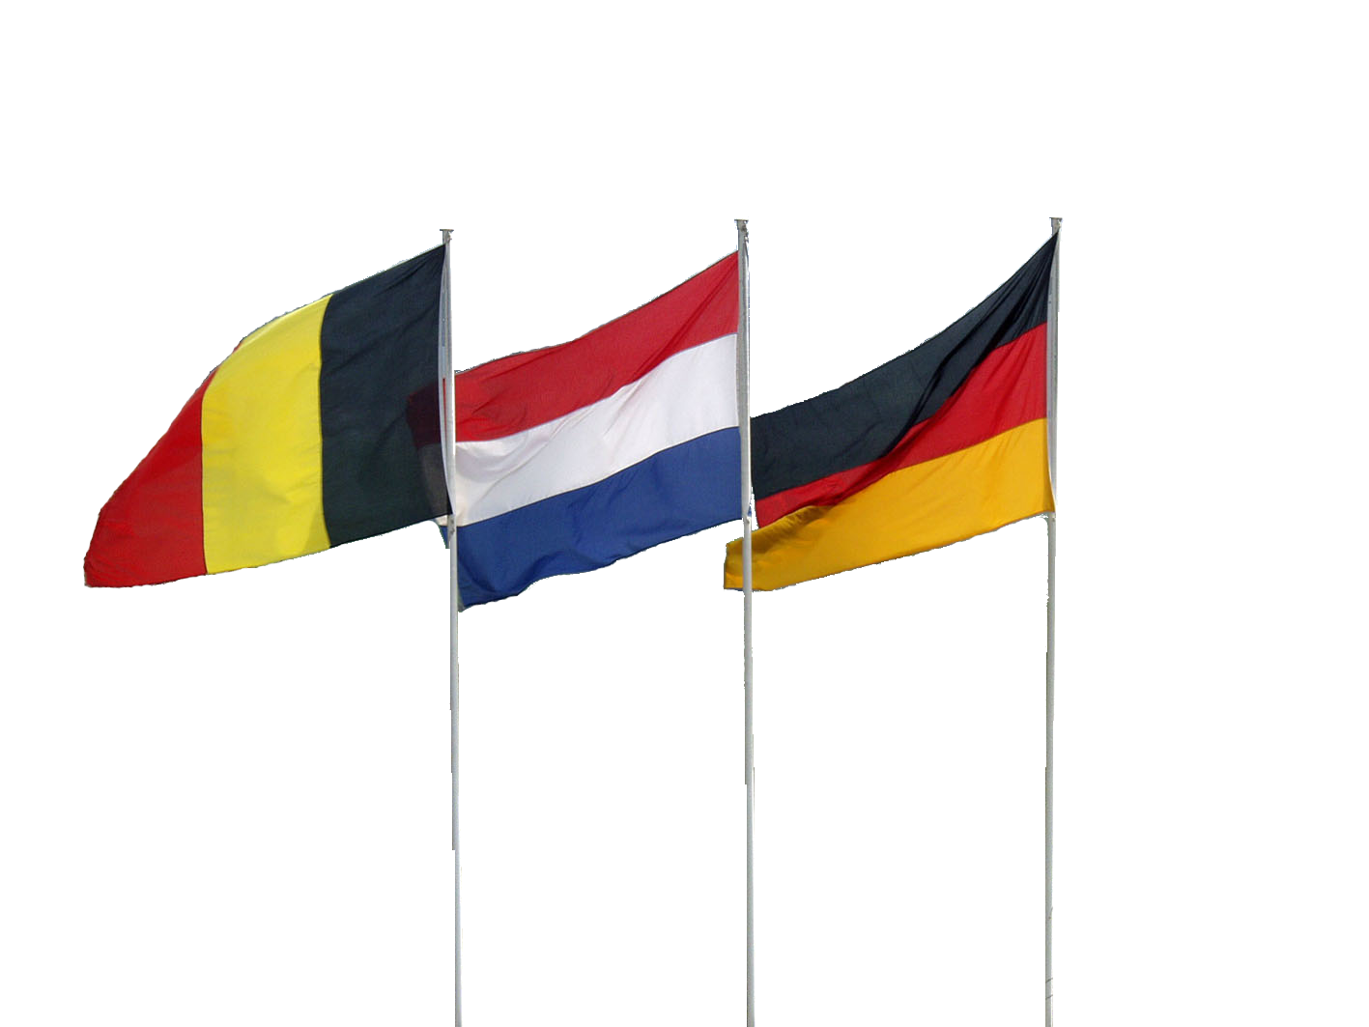
Conference Chairs: Prof. Dr. Gert Vriend, professor of Bioinformatics, CMBI and Dr. Gerry Nicolaes, 3D structure-function unit, Cardiovascular Research Institute Maastricht

