Referentie RP/ 2014 – RP824

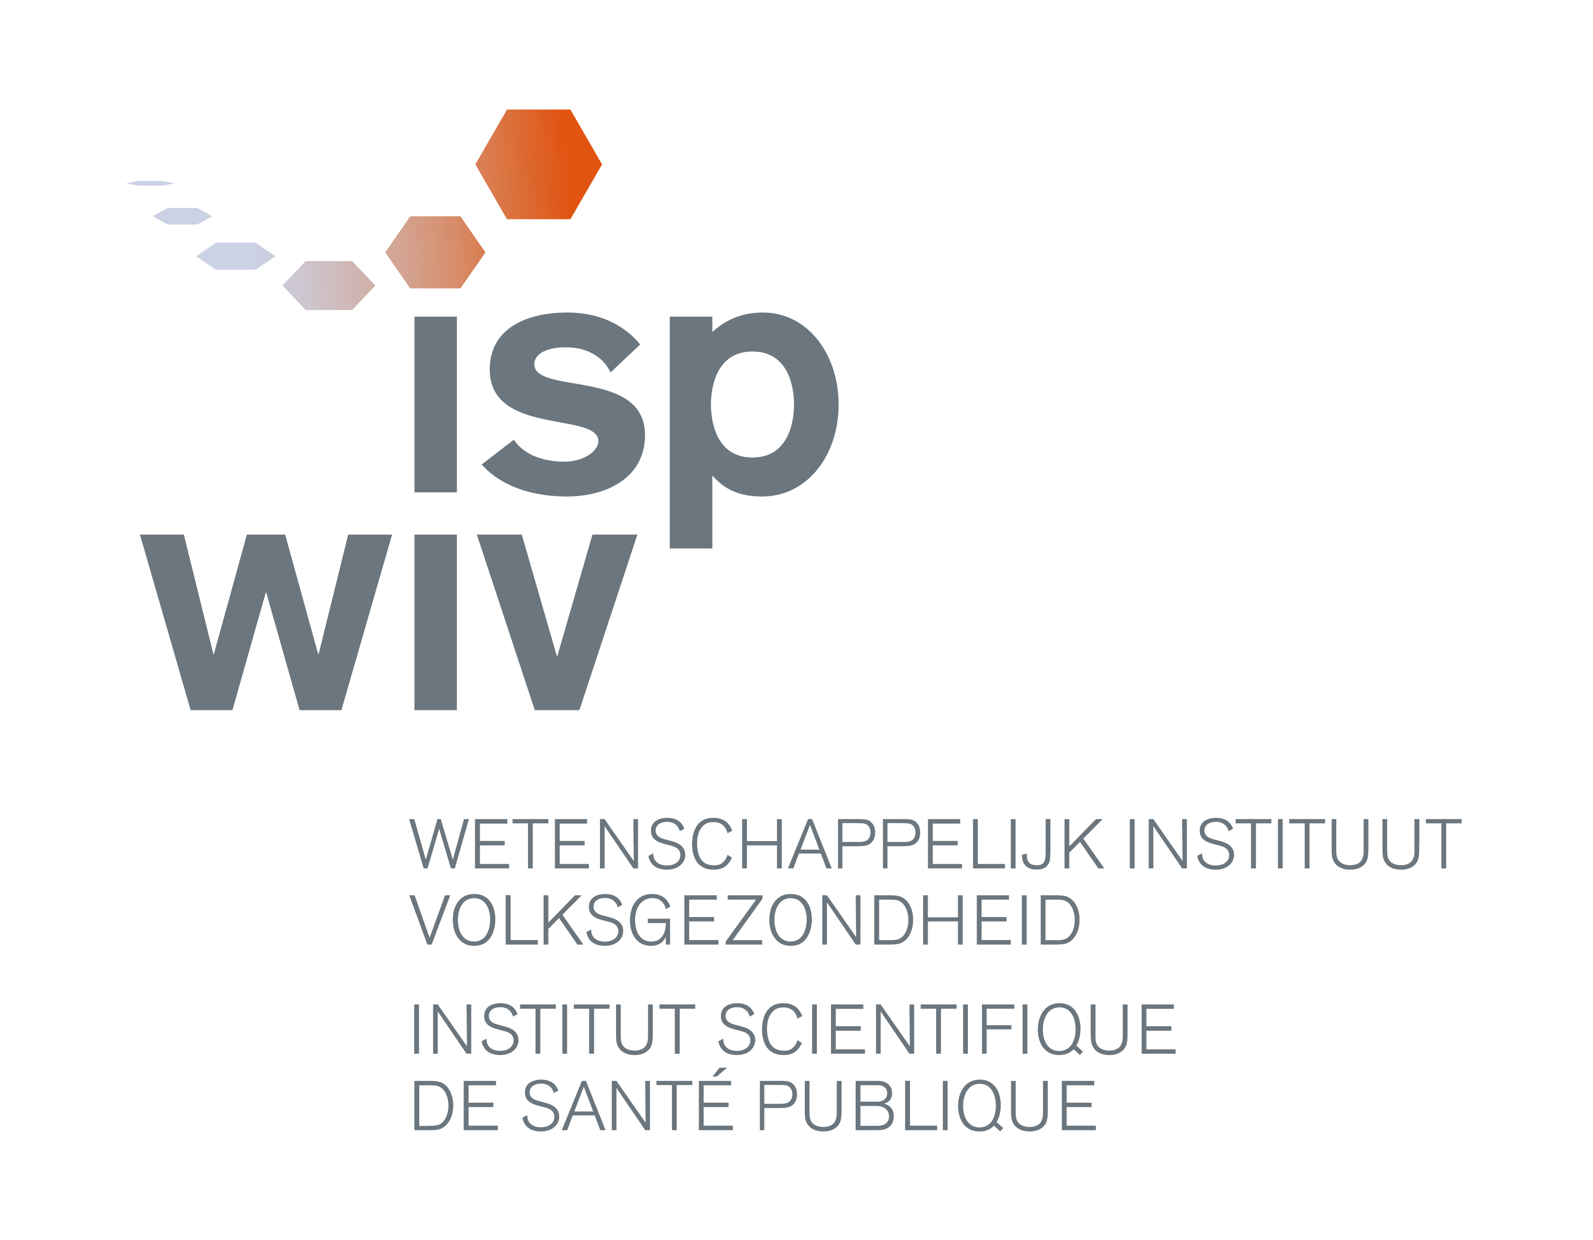
Vacant position :
Doctoral scholarship ‘Development of next generation sequencing data analysis tools in support of a fast response for public health and food chain safety’ (NeXSplorer.iph)
Master in bioinformatics (or equivalent)

The doctoral project

You will join the unit ‘Platform Biotechnology and Molecular Biology’ and will be responsible for the research project entitled: ‘NeXSplorer.iph: Development of next generation sequencing data analysis tools in support of a fast response for public health and food chain safety’.
You will be responsible for the organisation, execution and reporting of the research project ‘NeXSplorer.iph’.
About the project : recent advances and innovations in DNA-sequencing technologies are revolutionizing the ability to diagnose current and emerging diseases, to control outbreaks, understand transmission patterns of pathogens as well as to identify and prevent health risks associated with food consumption and environment. Indeed, the so-called the next generation sequencing (NGS) technology has emerged as a cost-effective and convenient approach for addressing many biological questions and therefore, it holds the potential to complement, and in the future even replace, many complex multifaceted procedures that are currently used to support a proactive public health policy, with a single, more efficient workflow.. While in the past NGS was exclusively applied as a research tool, with the continuous evolution of this technology, it will soon become sufficiently fast, accurate and cheap to be used in routine practice. However, as NGS costs continue to decrease, the challenge will not lay in producing NGS data but in the ability to rapidly analyse the massive amount of data obtained in order to extract and interpret the required information correctly.
This PhD project will address two NGS data analysis challenges with each a case study taken from current activities within the institute, with the aim to develop the appropriate pipelines (tools) for data analysis, later on applicable in routine. The first data analysis issue is related to the assembly of sequence-reads and the use of these data for pathogen outbreak investigation. The second data analysis issue is related to the time needed for full analysis of NGS data and the size of certain genomes, like the use of NGS for the detection and identification of authorized and unauthorized genetically modified organisms (GMO, UGM).
The objectives of this research are : 1) the development of data analysis tools for NGS data, applied to specific case studies related to public health issues; 2) the generation of knowledge (in the form of scientific publications and “in house” software/pipelines) related to the research lines and programs developed; 3) the obtaining of a Ph.D.
You are supported by senior scientists. The PhD-project is in collaboration with other scientific units of the WIV-ISP, i.e. Bacterial Diseases, Foodborne pathogens, Biosafety and Biotechnology and Viral Diseases and with a Flemish University.

Profile
Master in bioinformatics (or equivalent) - a strong mathematical or computational background
Knowledge of bioinformatics programming and statistics for bioinformatics, including programming languages (e.g. Java, C, C++), scripting (e.g., Python, Perl) and R.
An understanding of biological databases along with various Bioinformatics tools is required
Experience with Unix/Linux operating systems and with NGS data analysis is a plus
Familiar with or strong interest in molecular biology and microbiology
Willing to make a thesis dissertation
Able to synthesize, having a strong analytical mind
Able to work independently; having sense of responsibilities, organization and planning
Team player, with good communication skills
Able to speak, understand and write scientific papers and reports in English
Passive knowledge (i.e. understanding) of Dutch and French; active knowledge (i.e. understanding and speaking) of at least one of the two languages
Preferably 0-1 year of professional experience (master thesis included)

Offer
A 4-year doctoral scholarship

More information
Stefaan Vernaeve, Unit Personnel & Organisation - stefaan.vernaeve@wiv-isp.be - T 02/642.50.16
Sigrid De Keersmaecker, Responsible BIOTECHlab - sigrid.dekeersmaecker@wiv-isp.be - T 02 642 52 57

Interested? Send your application best before August 31st, 2014 via our website (http://www.wiv-isp.be/jobs) or by e-mail to jobs@wiv-isp.be.

