Ref. 14/WIS 01

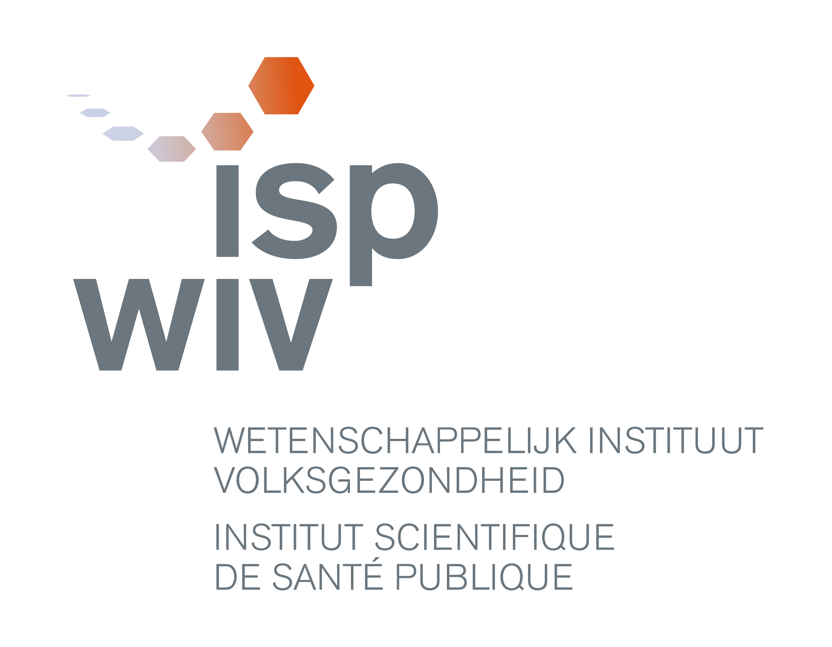
Job offer : Experienced bio-informatician (PhD)
Research unit: Platform Biotechnology & Molecular biology

Take up the challenge of big data in the post-genomics era to support public health

Job
- Perform extensive analysis of NGS data (mainly whole genome, with initial focus on microbial genomes) using state-of-the-art algorithms and techniques,
- Starting from a biological problem, identify and implement the proper state-of-the-art techniques to solve the problem based on literature search
- Design and develop new methods and tools for the analysis of NGS data, in collaboration with national and international bioinformatics institutes and networks
- Identify or develop software and hardware tools to manage, explore, display and analyse biological big (genomics) data (including databases)
- Attract funding to initiate bioinformatics scientific projects to address the needs for bioinformatics at the WIV-ISP in the context of public health
- Expand your working area gradually towards other bioinformatics applications
- Contribute to the training of other WIV-ISP scientists in bioinformatics
- Contribute to the establishment of, and eventually coordinate a centralized Bioinformatics Platform
- Valorise the developed analysis methods (scientific publications/ communications and patents)
- Work closely with (molecular) biologists, ICT staff, public health experts; cooperate with national and international bioinformatics institutes and participate in networks.
Profile
- University degree with strong mathematical background, preferable a Master of Engineering computer science, chemical/electrical engineering, mathematics with an additional master of Bioinformatics
- PhD, preferably in the field of bioinformatics applied to a biological question where NGS was used in collaboration with wet lab scientists; with at least 6 years of experience in bioinformatics
- Extensive experience in bioinformatics (incl. analysis of NGS data, excellent programming/computer science skills, in depth knowledge of statistics/datamining, development and implementation of data analysis pipelines, development of novel algorithms …)
- Track record of publications in the field of computational biology, analysis of NGS data sets
- Knowledge of molecular (micro)biological approaches and of DNA & RNA sequencing technology
- Experience with grant and proposal writing and project management (post doc)
- Very good knowledge in French and Dutch; excellent working knowledge of English
- Excellent interpersonal, verbal and written communication skills
- Team player; solution oriented; able to work on different projects in parallel, independently and in interaction with a team; accurate, respecting deadlines, excellent organizational skills; stress-resistant, strong strategic analytical, problem-solving skills; creative, critical and open mind; excellent at summarizing complex problematic, able to build strong collaborative relationships at all levels, proactive, user-oriented spirit; leadership skills
Offer
- A permanent position at the Scientific Institute of Public Health (WIV-ISP)
- Scale : SW21/31 (depending on expertise and experience)
- Gross monthly Salary :
- And other advantages
More information
Nancy Roosens, Head of Scientific Unit - nancy.roosens@wiv-isp.be - T 02 642 52 58
Sigrid De Keersmaecker, Responsible BIOTECHlab - sigrid.dekeersmaecker@wiv-isp.be - T +32 (0)2 642 52 57
Stefaan Vernaeve, service P&O - stefaan.vernaeve@wiv-isp.be - T 02/642.50.16
Interested? Send your CV by way our website (http://www.wiv-isp.be/jobs); or per e-mail to jobs@wiv-isp.be. Please indicate the ref. 14WIS01.

