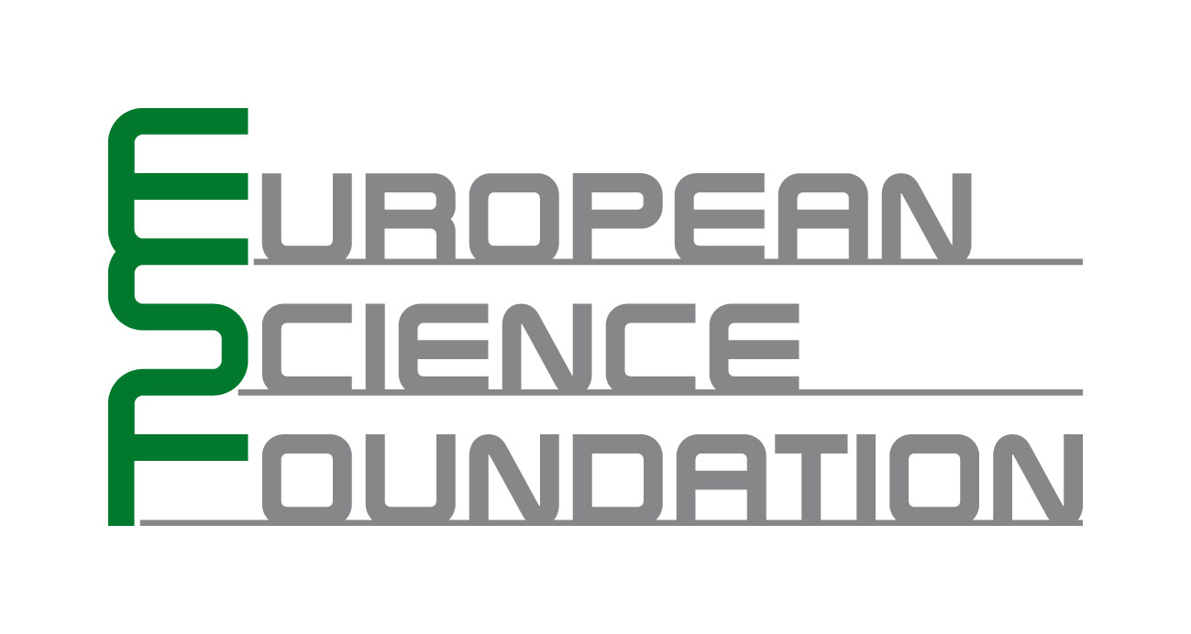 | RESEARCH CONFERENCES
Proposal Submission
▪ Practical Information
- Conference Title:
Structure and evolution of biological networks

- Proposed Chair of the Conference:
Prof. Dr. Other
First name: Yves Family name: Van de Peer
Organisation / University: VIB Department of Plant Systems Biology / Ghent University
E-mail: yves.vandepeer@psb.ugent.be Phone: + 32 (0) 9 33 13 807 Fax: + 32 (0) 9 33 13 809

- Co-Organizers (if appropriate):

- Proposed dates:
5/9/2009 – 10/09/2009

- Duration (usually five days):
5 days

- Expected number of speakers:
24 invited speakers + 6 speakers selected from the abstracts

- Expected number of participants:
Circa 100

- Keywords describing the Conference (up to five):
Network – Evolution – Inference – Topology - Interaction

- For assessment purposes, indicate which scientific areas are covered by the Proposal from the list below:

EMRC (European Medical Research Councils
ESSC (European Space Science Committee)
LESC (ESF Scientific Standing Committee for the Life, Earth and Environmental Sciences)
PESC (ESF Scientific Standing Committee for the Physical and Engineering Sciences)
SCH (ESF Standing Committee for the Humanities)
SCSS (ESF Standing Committee for the Social Sciences)

▪ Abstract (about one page)
Nowadays, geneticists are used to think “big”: whole-genome sequencing and genome-wide expression profiling are nearly everywhere. Translating these mountains of data into something meaningful is now the next challenge that scientists are faced with. The study of the structure of biological networks and their evolution is precisely trying to tackle this problem, by trying to make sense of the complex interactions between genes, proteins and other biologically relevant molecules. This research area is by necessity highly interdisciplinary, bringing together biologists, engineers, physicists and mathematicians in a coordinated effort to try to solve this gigantic puzzle. A considerable number of key papers published in this field were produced by European labs, and we think that it would be highly interesting and productive to set up a meeting on that topic through the ESF program. We would like to propose to focus on and highlight three fundamental topics: biological network inference, biological network evolution and dynamic modeling of biological systems.

Biological network inference
The development of methods for the reconstruction, or reverse-engineering, of biological networks remains a challenging and active area of research. In the past, reverse-engineering techniques have principally focused on decoding the mechanisms of transcriptional control, due to the availability of large microarray gene expression data sets. As high-throughput experimental technologies for protein and metabolite measurement continue to improve, researchers are now facing the challenge to extend their reverse-engineering techniques to these domains and obtain integrative models of interacting networks at different levels. Topics to be addressed at the workshop are reverse-engineering methodology, experimental and computational validation of reconstructed networks, and the use of partially validated network models for experiment design. Many European scientists contributed significantly to this field, like Denis Thieffry (France), Eileen Furlong (UK), Kathleen Marchal (Belgium), Naama Barkai (Israel), amongst others.

Biological network evolution
In this new era of “omics”, genomic and functional data are integrated from phylogenetically diverse organisms, to reconstruct key biological systems. Through the comparative method we can go a step further and understand how they emerged and later evolved to even more complex and fine-tuned systems. Chance and necessity, via the mechanisms of gene/genome duplication, gene loss, domain re-arrangement and point mutations have shaped biological systems that remain evolvable and robust, ready to adapt to and conquer new environments. This section of the workshop will focus on understanding the evolution and properties of gene regulatory, protein-protein interaction and biochemical networks. Significant contributions to the field are from the labs of Sarah Teichmann (UK), Christos Ouzonis (Greece), Anders Gorm Petersen (Denmark), Balazs Papp (Hungary), Sven Bergmann (Swiss), Peer Bork (Germany), Kenneth Wolfe (Ireland).

Dynamic modeling of biological systems
Dynamic modeling of biological systems is a broad and highly interdisciplinary field bringing together extensive biological expertise and state-of-the-art mathematical and engineering techniques. Examples include metabolic control analysis (MCA), the modeling of circadian rhythms, the yeast and mammalian cell cycles, embryonic development in Drosophila and sea urchin, leaf development and coral growth. Except for MCA, the use of detailed dynamical models has thus far been limited to relatively small-scale systems, mostly because the data (e.g. kinetic constants) needed to parametrize dynamical models are often lacking and the topology of the underlying biological networks is not well understood. As more and more relevant data become available and more biological network topologies get unraveled, the use of dynamical modeling techniques such as Boolean networks, Petri nets, differential equation models and stochastic models will likely increase significantly in the coming years. The research activity in this field is to a large extent centered in Europe, with names like Albert Goldbeter (Belgium), Béla Novak (Hungary), Hidde de Jong (France), Edda Klipp (Germany), Luis Serrano (Spain), Corrado Priami (Italy).

The most important meetings in this area of research are the International Conference on Intelligent Systems for Molecular Biology (ISMB) and the European Conference on Computational Biology (ECCB). But neither of those conferences is totally focused on the topic that we would like to cover for this ESF proposal. We truly think that bringing together the key players in the field of the structure of biological networks and their evolution will help to solve state-of-the-art problems and will be fruitful both for experienced and young scientists that will attend this meeting.

▪ Draft Programme
The three main sessions will be organized around the talks of the invited speakers (Inference of biological networks, Network evolution, Networks dynamic modeling). Each talk should last approx. 30 minutes with 10-15 minutes left for questions and discussion. A coffee break will be organized in each session, so that people can relax and discuss with each other. We will also put a very strong emphasis on the poster sessions, to promote interactions between the participants, especially towards young researchers. Poster sessions will be divided in even and odd numbers, so that everyone can have the chance to see all the posters with one of the authors standing by. There will be a significant numbers of talks selected from the submitted abstracts and we will organize a round table looking forward to the future of biological network evolution. Last, one afternoon is for free activities, leaving room for relaxation and open discussions.

Saturday 5/09/2009 – Registration and welcome

- Afternoon : registration.
- Welcoming remarks, Dr Yves Van de Peer.

Sunday 6/09/2009 – Inference of biological networks

Morning session speakers:
- Dr Kathleen Marchal, female, Belgian, Katholieke Universiteit Leuven, Network inference from heterogeneous data sources.
- Dr Ron Shamir, male, Israelian, Tel Aviv University, Analysis of gene expression and gene networks.
- Dr Jean-Philippe Vert, male, French, Center for Computational Biology, Kernel methods for gene expression analysis.
- Dr Olga Troyanskaya, female, American, Princeton University, Algorithms for the analysis of high-troughput expression data.

Poster session, even numbers.

Afternoon session speakers:
- Dr Tom Michoel, male, Belgian, Ghent University, Probabilistic frameworks for the inference of biological networks.
- Dr Eileen Furlong, female, Irish, EMBL, Integration of transcriptional and signalling networks.
- Dr Denis Thieffry, male, Marseille University, Bottom-up modelisation of gene networks.
- Dr Naama Barkai, female, Israelian, Weizmann Institute, Comparative genomics applied to the study of transcription regulation.

Poster session, odd numbers

Monday 7/09/2009 – Network evolution

Morning session speakers:
- Dr Sarah Teichmann, female, German, Medical Research Council UK, Structural information for gene networks.
- Dr Peer Bork, male, German, EMBL, Use of pathway analysis and genome context methods for functional genomics.
- Dr Christos Ouzonis, male, Greek, EMBL-EBI, Evolution of genetic information-processing systems.
- Dr Ken Wolfe, male, Irish, University of Dublin, Molecular evolution.

Poster session, odd numbers.

Afternoon session speakers:
- Dr Sven Bergmann, male, Swiss, University of Lausanne, Network modularity.
- Dr Anders Gorm Petersen, male, Danish, Technical University of Copenhagen, Molecular networks evolution.
- Dr David Robertson, male, British, University of Manchester, Bioinformatics and molecular evolution.
- Dr Balázs Papp, male, Hungarian, University of Manchester, metabolics networks and genome evolution.

Poster session, even numbers.

Tuesday 8/09/2009

Morning session: 4 speakers selected from abstracts.

Afternoon: free time activities.

Wednesday 9/09/2009 – Networks dynamic modeling

Morning session speakers:
- Dr Edda Klipp, female, German, Max Plank Institute for Molecular Genetics, Mathematical modeling of complex biological phenomena and diseases.
- Dr Hidde de Jong, male, Dutch, INRIA Rhone-Alpes, Modeling and simulation of genetic regulatory networks.
- Dr Bela Novak, male, Hungarian, Technical University of Budapest, Cell cycle modelisation.
- Dr Luis Serrano, male, Spanish, EMBL, Synthetic biology: designing biological systems from proteins to cells.

Poster session, odd numbers.

Afternoon session speakers:
- Dr Albert Goldbeter, male, Belgian, Brussels University, Theoretical chronobiology.
- Dr Johannes Berg, male, German, Cologne University, Statistical physics of disordered information.
- Dr Mark Siegal, male, American, New York University, Divergence of genetics networks and phenotypic evolution.
- Dr Corrado Priami, male, Italian, University of Trento, Computational and formal methods for systems biology.

Poster session, even numbers.

Thursday 10/09/2009

Morning session:
- 2-3 speakers selected from abstracts.
- Forward look plenary discussion.

Departure after lunch.

▪ Participation
(i) what criteria will apply in the selection of participants?
Participants will be selected upon their scientific merit and scientific needs.

(ii) how many young researchers are likely to be accepted (within the budgetary limitations)?
We would like to allow for a maximum of young researchers that the budget can allow for.

(iii) what proportion of participants is likely to be from outside Europe?
We can expect a significant number of participants from the US and probably also from Asia, where the study of biological networks is quite popular.

(iv) what is likely to be the largest national group?
The study of biological networks and their evolution is particularly well balanced in Europe, where many groups are working on the subject. We expect the different nationalities to be quite well balanced.

(v) what is likely to be the overall gender and geographical balance?
Given the actual statistics, we can expect an under-representation of female students in the audience, although this is quite difficult to estimate at the European level. Participants from western Europe are expected to constitute the majority of the meeting participants.

▪ Publicity
We have a list of more than 50 group leaders that are directly linked to the topic of the conference, plus we can include numerous systems biology and bioinformatics European mailing lists, such as the Benelux Bioinformatics organization.

▪ Additional Sponsorship

▪ Referees
Prof. Kenneth H. Wolfe
Smurfit Institute of Genetics
University of Dublin
Trinity College
Dublin 2
Ireland
Email khwolfe@tcd.ie
Telephone +353 1 896 1253
Fax +353 1 679 8558

Dr Peer Bork
EMBL - Biocomputing
Meyerhofstraße 1
69117 Heidelberg
Germany
Email bork@embl.de
Telephone +49-(0)6221-3870
Fax +49-(0)6221-387517

Dr Naama Barkai
Department of Molecular genetics and physics of complex systems
Weizmann Intistute of Science
Meyer building 404
Rehovot
Israel
Email naama.barkai@weizmann.ac.il
Telephone +972 8 934 4429
Fax +972 8 934 4108

