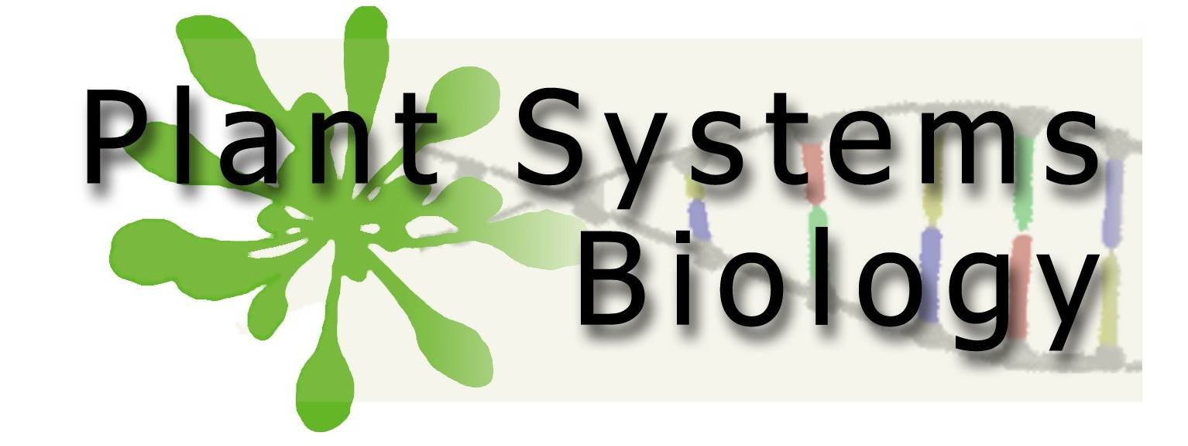

SEMINAR

We have the pleasure of inviting you and your colleagues to the following talk:

Tuesday 27th of May 2008
Kazuo Shinozaki
RIKEN Plant Science Center
Yokohama / JAPAN

“Regulatory gene network in plant drought-stress response”

14.00

Jozef Schell seminar room
Technologiepark 927
9052 GENT

Dirk Inzé

