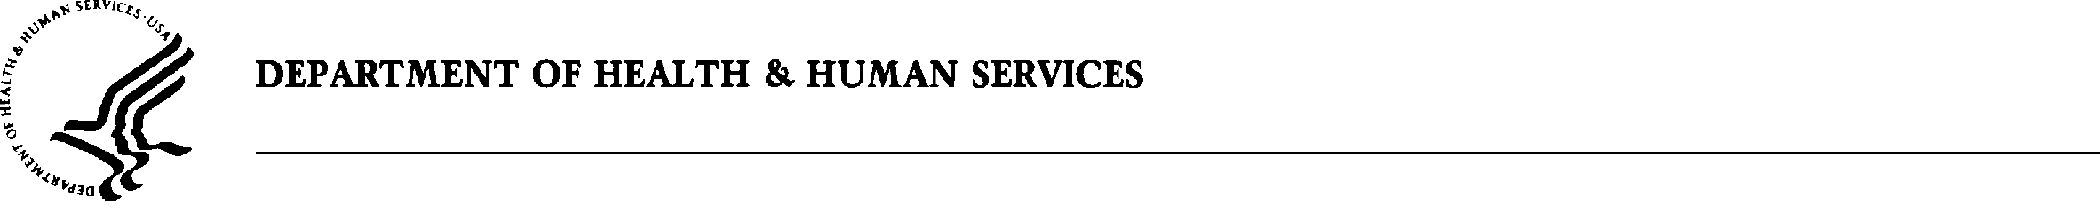
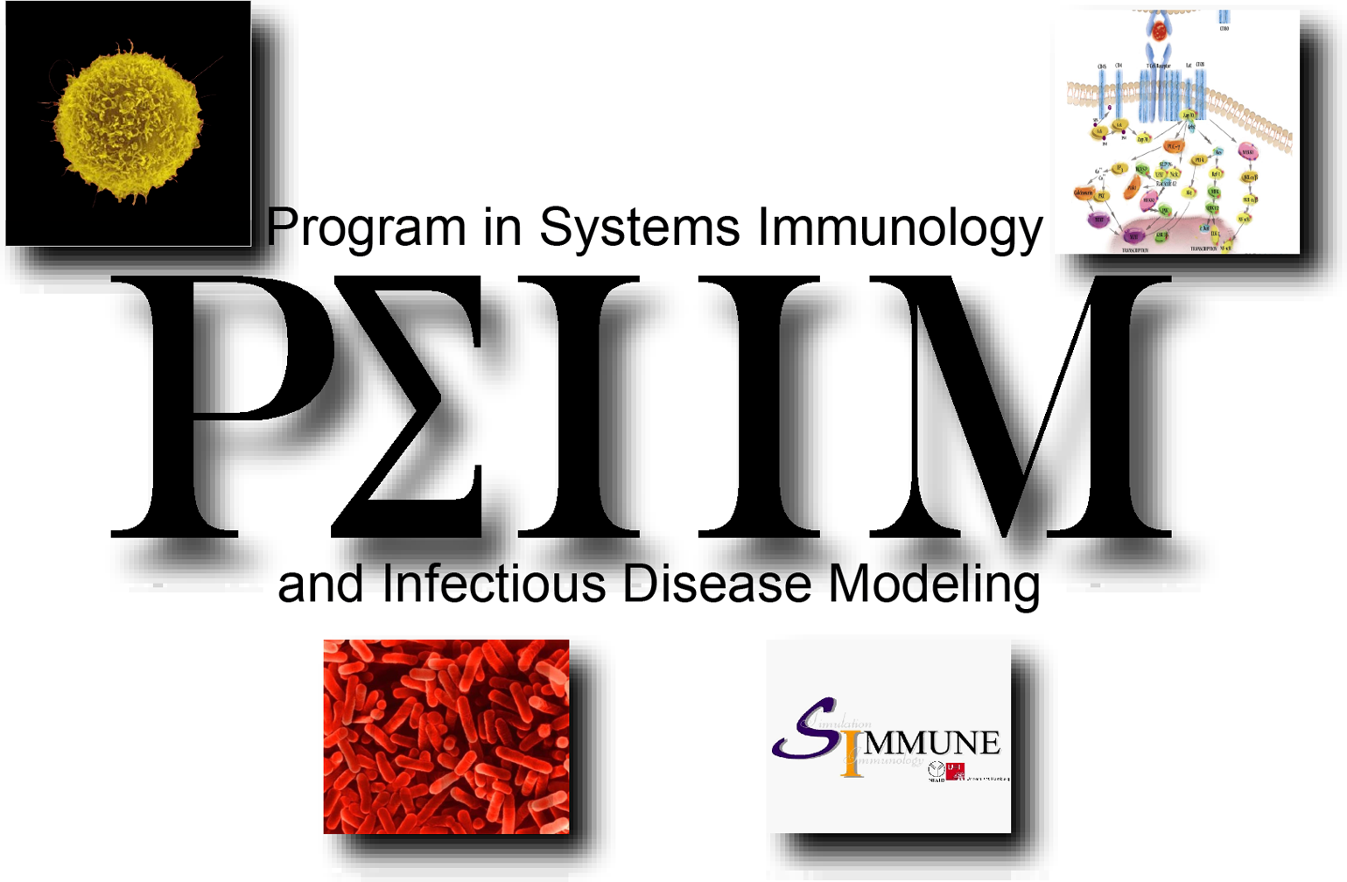
Ronald N. Germain, M.D., Ph.D.
Director, PSIIM
National Institute of Allergy and Infectious Diseases
National Institutes of Health
Bldg. 10, Rm. 11N311 MSC-1892
10 Center Drive
Bethesda, MD 20892-1892

Ph: 301-496-1904
FAX: 301-496-0222
E-mail: rgermain@nih.gov

Dr. Yves van de Peer
VIB / UGent
Bioinformatics & Evolutionary Genomics
Technologiepark 927
B-9052 Gent
BELGIUM
yves.vandepeer@psb.ugent.be

Dear Dr. van de Peer:

I am writing to bring to your attention the next round of faculty recruitment for the NIAID Intramural research effort called the Program in Systems Immunology and Infectious Disease Modeling (PSIIM), which is focused on combining computational modeling with quantitative experimental exploration of the immune system, pathogens, and host-pathogen interactions at various biological scales, from intracellular signaling and gene regulatory pathways to the whole organism level. These positions are fully supported by the Division of Intramural Research, NIAID, making them especially attractive in the current funding environment

The PSIIM has already recruited individuals to lead groups in the areas of computer modeling and simulation (Dr. Martin Meier-Schellersheim), molecular and cell biology/high throughput screening (Dr. Iain D.C. Fraser), proteomics (Dr. Aleksandra Nita-Lazar), and immunology (Dr. Ronald N. Germain, who also serves as PSIIM Director). As the attached advertisement details, the PSIIM is now recruiting to fill tenure / tenure-track positions in two remaining critical areas – bioinformatics and genomics. It is important to note that in contrast to most typical NIH intramural research activities involving small, focused, and quite independent laboratory groups, the PSIIM is organized around a ‘team science’ concept in which the various research groups headed by these recruits will be expected to devote a substantial amount of their effort towards larger, shared goals. To support career development in this new environment, NIH has modified its rules for granting tenure / assessing performance to take specific account of accomplishments made in a team setting. Support from internal NIAID research funds will be provided on a continuing basis that covers the salaries of the group leader, technical staff and fellows, along with generous budgets for equipment, laboratory reagents, animals, travel, and publication costs (or in the case of computational groups, computers, shared computing costs, and software licenses). The successful candidates will also be able to take advantage of numerous cores within the NIAID and NIH that include state-of-the-art support in the areas of gene microarrays, optical imaging, and cluster computing as well as both trans-NIH and PSIIM-specific robotics platforms for high throughput / high content drug and RNAi screening. The PSIIM also has purchased a next-generation sequencer whose use will be primarily devoted to the genomics recruit.

Although the PSIIM is currently supported solely by the NIAID, it is already providing leadership across the NIH in the area of computational systems biology and it is expected to continue in this role as NIH develops a trans-Institute effort in this area in the future. The tenure / tenure-track positions now open in the PSIIM thus represent extremely attractive positions for individuals interested in playing a key role in creating and applying new methods for quantitative analysis of biological systems. The PSIIM will invest heavily in the development of novel, broadly applicable tools for systems biology research, with an emphasis on software for modeling and simulation [for example, see PLoS Comput Biol. 2006 Jul 21;2(7):e82. Epub 2006 May 25, PMID: 16854213], the integration of this software with bioinformatics applications, and the establishment of methods for providing the numerical data necessary for computational efforts. The PSIIM will conduct biological studies in the areas of immunology and infectious diseases, taking maximal advantage of the latest technological advances, but extension of the systems approach of the PSIIM to other areas of biomedicine will be possible through collaboration. The integrated, multidisciplinary nature of the PSIIM research effort is expected to markedly facilitate its ability to make significant contributions in the arena of complex biosystems analysis. Studies of the host immune system will include such topics as signaling by microbial receptors (TLRs, NODs, and RIGI), regulation of differentiation of T cell subsets, and tissue level as well as whole body analysis of protective and pathologic innate and adaptive immune responses to infectious agents. Pathogen biology will also be a focus of PSIIM efforts, with studies ranging from signaling networks and gene regulatory pathways controlling pathogenicity to determination of points of vulnerability to drug therapy or immune effectors.

I ask that you bring this exciting new program and the group leader positions being advertised to the attention of any outstanding fellows or colleagues you believe have an interest in systems biology, irrespective of their background in immunology. A new website is currently under construction that will provide additional information about the PSIIM and its research program, but for now the recruiting advertisement provides a good, if brief, introduction to the available opportunities. Additional information about the PSIIM is available in an article at http://www.nih.gov/catalyst/2006/06.09.01/page1.html
and also at http://www3.niaid.nih.gov/labs/aboutlabs/psiim/.

With thanks in advance for your help,

Sincerely yours,
Ronald N. Germain, M.D., Ph.D.
Director, PSIIM

