Reconstructing gene expression networks by combinatorial analysis of perturbed expression profiles

Steven Maere¹, Patrick Van Dijck² and Martin Kuiper^{1, 3}

¹Department of Plant Systems Biology, Flanders Interuniversity Institute for Biotechnology (VIB), Ghent University, Technologiepark 927, B-9052 Ghent, Belgium
²Department of Molecular Microbiology, Flanders Interuniversity Institute for Biotechnology (VIB), Laboratory of Molecular Cell Biology, Katholieke Universiteit Leuven, Kasteelpark Arenberg 31, B-3001 Leuven, Belgium

³ Corresponding author
E-mail: Martin.Kuiper@psb.ugent.be
Tel: + 32 (0)9.331 3805
Fax: + 32 (0)9 331 3809
Kuiper’s lab: http://www.psb.ugent.be/cbd/

Running title: Combinatorial analysis of expression profiles
Character count: 57,859
Subject Categories: Simulation and data analysis, Computational methods

Abstract

One of the goals of systems biology is to unravel the regulatory wiring of living organisms by systematically perturbing conditions, genes and pathways, measuring the resulting molecular phenotypes on a genome-wide scale, and integrating these data into models that describe and predict the behavior of the system. In this respect, large-scale compendia of gene expression profiles under chemical, environmental or genetic perturbations constitute an invaluable resource. However, because of their perturbational nature, these datasets are particularly recalcitrant to computational analysis. Here, we present a novel method, based on combinatorial statistics and graph theory, to extract partial expression correlations from large-scale perturbational microarray data and to build a network of overlapping expression modules. We applied our method to the Rosetta compendium of expression profiles for S. cerevisiae, and show that the resulting fine-grained coexpression network not only advances the functional study of specific genes, subsystems and pathways, but that it also provides a better resolution of the global network topology and the crosstalk between modules.

Keywords: combinatorial statistics/gene expression network/microarray data analysis/systems biology/transcriptional modules

Extended Synopsis

One of the goals of systems biology is to unravel the regulatory wiring of living organisms by systematically perturbing conditions, genes and pathways, measuring the resulting molecular phenotypes on a genome-wide scale, and integrating these data into models that describe and predict the behavior of the system (Ideker et al, 2001). In this respect, large-scale compendia of gene expression profiles under chemical, environmental or genetic perturbations constitute an important resource. However, in such perturbational datasets, genes do not necessarily show similar expression behavior under all experimental conditions: they may be coexpressed under some perturbations, and show uncorrelated or even inversely correlated expression under other perturbations. Consequently, perturbational expression profiles cannot be compared adequately using the global similarity measures used in most clustering methods, such as Pearson’s correlation coefficient (PCC), since these only capture global trends of co- or antiregulation.
Therefore, biclustering strategies were developed that can detect subsets of genes that exhibit similar expression behavior across a subset of conditions. Several biclustering strategies exist today, each using its own heuristic approach to tackle this complex problem (Madeira and Oliveira, 2004 and references therein). However, most of these methods avoid pair-wise comparison of expression profiles, instead focusing on the emerging properties of groups of genes and conditions in order to uncover statistically significant subpatterns in the data. Although these methods are perfectly capable of finding biologically relevant biclusters, their inability to compare individual expression profiles can be a disadvantage in some situations. For example, the study of the expression behavior of particular pathways or other subnetworks, such as the transcription factor network, requires a finer-grained coexpression network, where the correlations between individual components are resolved.
Here, we introduce a combinatorial statistic (CS) that, contrary to existing methods, probes partial expression correlation between individual genes. The probabilistic nature of our approach allows us to assign a P-value to each correlation and to apply multiple testing corrections. The resulting detailed network of significant partial expression correlations is clustered into overlapping modules using a graph clustering algorithm that basically identifies densely connected components in the graph, generating a higher-level representation of the modularity in gene expression. A global overview of the methodology is given in Figure 1.
We tested our approach on the Rosetta compendium of expression profiles for S. cerevisiae, representing data on 300 different experimental perturbations (Hughes et al, 2000) and compared the resulting CS coexpression network with the coexpression network obtained with PCC, a global similarity measure. We found that the CS network shows enhanced resolution of the processes originally perturbed by Hughes et al (2000), whereas the resolution of processes that are less related to the applied perturbations is suppressed. Thus, the CS network provides a more detailed and focused view on the processes under study. When comparing the global topological characteristics of the coexpression networks obtained with CS and PCC, we found that, relative to the PCC network, the CS network is enriched in highly connected but loosely clustered nodes that belong to multiple modules, i.e. hubs that provide links between different transcriptional modules. These results confirm that CS efficiently captures partial correlations in expression and hence crosstalk between expression modules.
Furthermore, we show that a fine-grained network of pair-wise partial correlations can advance the study of specific genes, subsystems or pathways. One of the regulatory networks that can be probed to a certain extent using microarray data is the transcription factor (TF) network. We applied our method to the TF network in S. cerevisiae and found that the CS-based TF network, in contrast with the PCC-based TF network, shows a considerable overlap with the TF network obtained from ChIP data (Harbison et al, 2004). Moreover, when discarding transcription factors with very few ChIP targets (i.e. those for which ChIP-based target identification might have been less efficient), the overlap improved, which suggests that CS might be useful for predicting interactions that were missed by ChIP analysis.
One of the main goals of the method proposed here is to decompose the data into interesting subparts that can be analyzed in more detail to generate hypotheses that can be tested in the lab. We assessed such use in an analysis of the mating system of S. cerevisiae, and we identified several candidate genes previously unknown to be involved in mating. In addition, we were able to discriminate a subset of mating-related genes involved in multiple modules and characterized by a distinctive expression pattern (Figure 5). These genes are coexpressed with the TEC1 gene, which encodes a transcription factor that is believed to mediate an invasive growth response upon low levels of pheromone signaling (Bao et al, 2004). Furthermore, these genes are specifically downregulated upon TEC1 deletion, but they seem to lack Tec1 binding motifs in their promoters. Instead, several of them are closely linked to antisense Ty1 long terminal repeat (LTR) elements. Intriguingly, TEC1 was first identified as a gene required for full Ty1 expression (Laloux et al, 1990). We propose that TEC1 influences the expression of these genes through interaction with the Ty1 LTRs, and that this effect could be functionally relevant for the mating process. We provide evidence that at least two Ty1 LTR associated genes, namely YLR343W and YLR334C, cause mating-related phenotypes upon deletion, and we formulate hypotheses concerning their function. Although further experimentation is needed to confirm or disprove these hypotheses, these results show that the method proposed here is able to drive wet-lab research.
Although many different approaches have already been used to mine the Rosetta compendium, our analysis method allows us to uncover yet novel information from the data. This demonstrates that no single approach can extract all the information hidden in large compendium datasets. The elucidation of the regulatory networks governing the many different aspects of cellular function will therefore not only require the integration of different types of data, but also the integrated use of several complementary methods to analyze these data. We believe that our method constitutes a powerful addition to the existing repertoire of analysis methods.

Introduction

Over the last decade, the availability of fully sequenced genomes and the development of high-throughput technologies such as DNA microarray-based transcript profiling have fuelled an exponential increase in the volume of functional genomics data. This has led to a renewed interest in the study of molecular biology at the system level (Kitano, 2002; Ideker et al, 2001; Hohmann, 2005).
The paradigm in systems theory is that one can learn about a system by perturbing it and measuring the response. This principle also applies to biological systems. Since mRNA levels can nowadays easily be measured on a genome-wide scale, expression profiling has become a first method of choice for assessing the molecular response to experimental perturbation (the molecular phenotype). Considerable efforts are put into creating compendia of expression profiles under genetic, chemical or environmental perturbations (Hughes et al, 2000; Kim et al, 2001; Lee et al, 2003) or in different tissues (Kim et al, 2001; Zhang et al, 2004; Schmid et al, 2005). Such data compendia basically constitute a series of snapshots of expression states under these conditions, and they contain a wealth of information concerning the underlying transcriptional network structure of an organism. The challenge now is to devise methods to efficiently and reliably extract that information.
Clustering of DNA microarray data allows the inference of functional correlations through what was dubbed the ‘guilt-by-association’ principle (Walker et al, 1999). A classical clustering process generally consists of two steps (Eisen et al, 1998). First, a matrix of distances between expression profiles is calculated using a distance or similarity measure, such as Pearson's centered correlation coefficient (PCC). Based on this distance matrix, the actual clustering algorithm, for instance average linkage hierarchical clustering, groups similar profiles together. Traditional distance measures such as PCC are well suited for analyzing time-series microarray data, but they fall short when applied to perturbational data, because they only capture global tendencies of co- or antiregulation. In compendia of perturbed expression profiles, genes do not necessarily show similar behavior under all experimental conditions: they may be coexpressed under some perturbations, and show uncorrelated or even inversely correlated expression under other perturbations.
This observation stimulated the development of alternative clustering strategies. The process of detecting subsets of genes that exhibit similar expression behavior across a subset of conditions is known as biclustering. Several biclustering strategies exist today, each using its own heuristic approach to tackle this complex problem (Madeira and Oliveira, 2004 and references therein). Some biclustering methods use a greedy iterative search strategy to uncover biclusters, progressively subdividing, or adding and removing rows and columns from the biclusters obtained in a previous iteration in order to maximize a local score function (Cheng and Church, 2000; Getz et al, 2000; Ihmels et al, 2004). Others use linear algebra (Kluger et al, 2003) or adopt a graph-theoretic approach to biclustering (Tanay et al, 2002). Yet other methods identify biclusters by proposing a statistical model and estimating the distribution parameters that minimize a certain model fit criterion (Lazzeroni and Owen, 2002; Segal et al, 2003a; Segal et al, 2003b; Sheng et al, 2003).
Evidently, a wide variety of biclustering algorithms exist, each of them having their own strengths and weaknesses. For example, some of these methods are intrinsically less suited to find overlap between biclusters because they mask previously found biclusters with random noise (Cheng and Church, 2000; Sheng et al, 2003), or because they inherently partition the data (Kluger et al, 2003). However, a feature that most of the existing methods share is that they do not explicitly define similarity measures on the global space of expression profiles that are capable of detecting pair-wise partial correlations between individual genes or conditions. Some methods (Getz et al, 2000) use local measures instead, i.e. they calculate a standard pair-wise distance measure between two genes/conditions on a subset of features (conditions/genes). However, most algorithms (Cheng and Church, 2000; Tanay et al, 2002; Ihmels et al, 2004; Lazzeroni and Owen, 2002; Kluger et al, 2003; Segal et al, 2003a; Sheng et al, 2003) avoid pair-wise comparison of genes or conditions altogether, instead focusing on the emerging properties of groups of genes and conditions in order to identify statistically significant subpatterns in the data. Although these methods are perfectly capable of finding biologically relevant biclusters, their inability to compare individual expression profiles can be a disadvantage in some situations. For example, the study of the expression behavior of particular pathways or other subnetworks, such as the transcription factor (TF) network, requires a finer-grained coexpression network, where the correlations between individual components are resolved. The functional study of single genes might also benefit from high-resolution coexpression analysis. For example, Wu et al (2002) demonstrated that, in order to predict the function of an uncharacterized gene, simply analyzing the functional profile of the top-10 correlated genes is more efficient than analyzing the output of any of the clustering algorithms they tested. Traditional similarity measures, such as PCC, meet this resolution requirement, but they are less suited to uncover partial correlations in expression.
Here, we introduce a combinatorial statistic (CS) for pair-wise comparison of perturbed expression profiles. The probabilistic nature of our approach allows us to assign a P-value to each correlation and to apply multiple testing corrections. The resulting significant correlations are translated to edges in a coexpression network, which is then clustered into expression modules using a greedy graph clustering algorithm. A global overview of the methodology is given in Figure 1.
The aims of this study are: (i) to develop a method which can extract partial expression correlations between individual genes, (ii) to construct a detailed coexpression network based on perturbational microarray data for budding yeast (Hughes et al, 2000), identify expression modules from this network and assess overlap or crosstalk between modules, (iii) to study the properties of the coexpression and module networks in relation to a coexpression network generated with PCC, a global similarity measure, (iv) to integrate the coexpression network with chromatin immunoprecipitation (ChIP) data (Harbison et al, 2004) and study a specific subnetwork, namely the TF network, to assess the finer-grained analysis potential of our method, (v) to predict the function of uncharacterized genes, or additional functions for known genes, based on their position in the coexpression network, and (vi) to validate some of these predictions in vivo, and to illustrate the potential of the CS method to drive wet-lab research, by focusing on the mating system in S. cerevisiae.

Results and discussion

Coexpression network definition and resolution: CS versus PCC

We tested our methodology on the Rosetta compendium of expression profiles for S. cerevisiae, representing data on 300 different experimental perturbations (Hughes et al, 2000). In order to compare our combinatorial statistic (CS) with global distance measures, the expression profiles of all genes were correlated with PCC in addition to the CS described in the Methods section. In both cases, we constructed a coexpression network in which the nodes represent genes and the edges represent significant expression correlations. The construction of these networks requires setting a threshold for the significance of expression correlations. While the choice of a threshold for the CS network naturally follows from the statistical formalism, setting a threshold for PCC significance is less obvious. In theory, it is possible to determine whether a PCC is significantly different from zero by assuming that the distribution of correlations under the null hypothesis of no correlation follows a t-distribution with 298 (300 experiments -2) degrees of freedom. Adopting a (conservative) Bonferroni correction in order to control the family-wise error rate at α = 0.01, the critical PCC would be of the order of 0.02, which is of no practical use. Instead, we determined a PCC threshold by requiring that the overall density of connections be similar in the CS and PCC subnetworks encompassing only the nodes (genes) shared between the two networks. However, our results are qualitatively independent from the PCC threshold choice.
Using a false discovery rate (FDR) threshold of 0.01, the combinatorial statistic identified 61,694 and 9,182 significant positive and negative correlations, respectively, involving 2,306 genes. For the construction of the PCC network, a Pearson correlation threshold of +/- 0.5 was used. Within the subnetworks containing shared nodes (2,146) only, the number of edges for PCC (62,748 positive and 21,638 negative) is in the same order of magnitude as that for CS (59,498 positive and 8,672 negative). 42,970 positive edges and 3,536 negative edges are shared between the CS and PCC networks. The total PCC network contains 145,353 positive and 72,015 negative correlation links between 4,979 genes.
Figure 2F depicts the difference between both networks in the number of positive links (node degree k, only positive edges) for each of the 6,132 S. cerevisiae genes. The set of genes with a higher degree in the PCC network is mainly enriched in ribosomal genes (see Figure S1). On the other hand, the set of genes with a higher degree in the CS network is highly enriched in genes involved in a.o. conjugation (mating), ergosterol metabolism, (iron) ion transport, amino acid biosynthesis, cell wall organization and biogenesis, and genes whose function is still unknown (see Figure S2). Many of these categories are closely related to the pathways that were perturbed in the original experiments (Hughes et al, 2000) (Figure S3). So, while it might be argued that information is lost by discretizing the expression data, as done for the CS network (see Methods and Figure 1), we observe that the resolution of the CS network, in terms of edge counts, is actually better for the processes that are targeted by or responding to the applied perturbations. Connections between genes that show similar global expression behavior but do not specifically respond to the perturbations (little or consistent up- or downregulation, regardless of the perturbations applied), such as ribosomal genes, are generally better resolved in the PCC network.

Clustering and integration with ChIP data

Both networks were clustered using a greedy graph clustering procedure designed to identify densely connected components in a network (see Methods). Our clustering procedure depends on two parameters that control the size and density of individual clusters (ν₁), and the overlap between clusters (ν₂). After testing several parameter configurations, we used the values (ν₁, ν₂) = (0.55, 0.45) for both the CS and the PCC networks (see Methods and Figure S4). A global overview of the resulting CS expression module network is shown in Figure 3. For each gene module, we determined the relevant condition set as described in the Methods section. Detailed lists of the genes included in each module, as well as the full condition sets for each module, can be found in the supplementary data. All gene clusters were annotated using GO (The Gene Ontology Consortium, 2000) (see Methods and supplementary data). From Figure 3, it is obvious that most modules have a moderate to high degree of functional coherence, indicating that our method indeed uncovers biologically relevant expression modules.
To confirm this, we screened each module for enrichment of ChIP-determined targets for 102 TFs (Harbison et al, 2004). We found that most modules are indeed enriched in targets of one or more TFs. Adjacent modules frequently differ in only one or a few TFs, and, with only three exceptions, no two modules are linked to the exact same set of TFs. Taken together, this suggests that these TFs are at least partially responsible for the regulation (and hence formation) of the expression modules. Consequently, genes in the intersection of multiple modules should be bound by more TFs than genes found in a single module. Indeed, we found a weak but significant correlation between the number of modules that a gene belongs to and the number of TFs that bind it (Spearman rank correlation 0.109, P = 1.55E-07). A similar analysis on the PCC network yields a considerably lower correlation (Spearman rank correlation 0.048, P = 7.84E-04), indicating that the CS algorithm is better than PCC in identifying overlap between modules. The fact that the correlation is weak is understandable considering that the 276 gene deletion strains profiled in the Rosetta compendium (Hughes et al, 2000) represent less than 5% of the genome. However, it remains to be seen whether the correlation will improve when more perturbations are analyzed.

Global topological characteristics

Since many cellular functions are carried out in a highly modular manner (Hartwell et al, 1999), most cellular networks, including protein interaction networks, metabolic networks and gene expression networks, are modular in nature (Ihmels et al, 2002; Ravasz et al, 2002; Bar-Joseph et al, 2003; Rives and Galitski, 2003; Han et al, 2004; Barabási and Oltvai, 2004). On the other hand, many cellular networks, including coexpression networks, have been claimed to exhibit a node degree (k) distribution of the power-law type, P(k) ~ k^{-γ}, indicating that they have scale-free properties (Albert and Barabási, 2002; Barabási and Oltvai, 2004; Bergmann et al, 2004). The coexistence of modularity and a scale-free degree distribution can be explained by assuming a hierarchical modular network organization (Ravasz et al, 2002; Barabási and Oltvai, 2004; Bergmann et al, 2004). According to this view, the network consists of a hierarchy of nested topological modules of increasing size and decreasing coherence. In other words, small coherent modules combine to form larger and less coherent modules in a hierarchical fashion. At reasonable levels of module resolution, the modules consist mainly of sparsely connected but highly clustered nodes (low k, high C). The modules are linked together through a small number of highly connected nodes with a low clustering coefficient (high k, low C), often referred to as hubs. In the case of coexpression networks, these hubs represent genes that are linked to different expression modules depending on the experimental conditions.
We investigated the global topological characteristics of the coexpression networks obtained with PCC and CS (only positive correlations were taken into account, hence k is the positive degree of a node). A few papers (Amaral et al, 2000; Tanaka et al, 2005) have cast doubt on the ubiquity of power-law degree distributions in biological networks, claiming that some of the supposed power-laws actually turn out to be closer to exponentials when rigorously analyzed. Indeed, the degree distributions of both the PCC and the CS network both appear to be exponentially distributed (Figure 2A and 2B), at least for lower k. For higher k, the picture is different. Relative to the distribution obtained for lower degrees, the most highly connected nodes (hubs) seem to be underconnected. Especially for the PCC network, there seems to be a degree cutoff. This observation is exactly the opposite of what would be expected for a power-law (‘fat-tailed’) degree distribution (i.e. highly connected nodes should be overconnected with respect to the exponential distribution), indicating that the coexpression hubs are not nearly as central in the network as would be the case in a scale-free network. However, from the plots of the clustering coefficient C versus the degree k (Figure 2C and 2D), it is apparent that the highly connected nodes still possess hub-like characteristics: they generally have a lower clustering coefficient and are assigned to multiple modules. Thus, highly connected nodes act more as local hubs that hold together a few modules. However, the PCC and CS networks are markedly different in this respect. In the CS network, the most highly connected genes have very low clustering coefficients and belong to six or more modules, suggesting that they are genuine hubs that provide links between different, otherwise unconnected transcriptional clusters. In contrast, the number of genes in the PCC network belonging to multiple clusters is more limited, and their topological hub-characteristics (high k, low C) are less pronounced. This difference could be partially due to the lower overall density d in the PCC network (d = 0.012 versus d = 0.023 for the CS network; d is the number of actual edges in the network divided by the number of possible edges in the network, which is n(n-1)/2 for a network of n nodes), yet for the PCC subnetwork restricted to CS nodes (Figure 2E), which has nearly the same density (d = 0.024) as the CS network, the difference is even more striking. These results indicate that CS, more than traditional distance measures, is able to uncover crosstalk between expression modules.
The hubs in the CS network, by virtue of their polytomous expression behavior, could be good candidates for key metabolic or regulatory functions. In order to assess whether particular functional classes of genes are more likely to belong to multiple clusters, we functionally profiled the hubs in the CS and the PCC networks using their GO Slim annotation and BiNGO (Maere et al, 2005). Relative to all genes on the microarray, the set of CS hubs is enriched (at FDR = 0.05) in cell wall, extracellular region and plasma membrane genes, oxidoreductases, vitamin, carbohydrate and amino acid metabolism genes, transporters and conjugation related genes (see Table I). However, when the hubs are profiled relative to all genes in the CS network (i.e. the genes that show a substantial response to the perturbations), most of these categories are no longer overrepresented (Table I), which means that the apparent enrichment of these functional categories among hubs is probably the result of the particular experiments performed by Hughes et al (2000), rather than being the reflection of which kind of genes are truly more likely to show perturbation-dependent association with several expression clusters. The PCC hubs are also moderately enriched in cell wall and carbohydrate metabolism genes when profiled against all genes on the microarray, as well as highly enriched in ribosomal genes, even when profiled against the PCC network. However, ribosomal genes are underrepresented among CS hubs (P = 9.97E-07), leading us to believe that their enrichment in PCC hubs is an artifact. Although no functional trends are found among hubs, individual hubs might still represent genes that hold key positions in the response to the applied perturbations (see below).

Reconstruction of the ChIP-based TF network

To assess the potential of our method for finer-grained analysis, at the level of partial correlations between individual genes, we studied a specific subnetwork, namely the TF network (i.e. the set of interregulatory relationships between TFs). As a template, we used an interregulatory network for 102 TFs, derived from the ChIP data generated by Harbison et al (2004). Self-regulatory interactions were not taken into account. The resulting ChIP TF network contains 206 interactions involving 79 of the 102 TFs. We investigated which portion of this network could be reconstructed based on the Rosetta expression profile compendium, using CS and PCC (see Methods). The TF network details can be found in the supplementary data.
The CS method uncovers 38 coexpression relationships between the 102 TF, 9 of which are confirmed by the ChIP network. In contrast, the PCC method yields 67 edges, only 5 of which are confirmed by ChIP. Because a lot of the ‘false positive’ edges in the CS TF network emanate from TFs with only a few or no connections in the ChIP TF network, we investigated whether these nodes could represent TFs that are less amenable to ChIP-based target identification. In this case, some of the unconfirmed edges in the CS TF network could be false negatives in the ChIP network. Indeed, several of the TFs were found to have very few ChIP targets genome-wide, which suggests that ChIP was less efficient for these TFs. When we subsequently discarded TFs with fewer than 5, 10 (see Figure 4) or 15 ChIP targets, the fraction of confirmed edges in the CS TF network increased from 9/38 (23.7%) in the full network to 6/21 (28.6%), 6/16 (37.5%) and 6/14 (42.9%), respectively, whereas the fraction of confirmed edges in the PCC TF network remained relatively stable, going from 5/67 (7.5%) to 2/43 (4.7%), 2/36 (5.6%) and 2/32 (6.3%) respectively.
Thus, some of the unconfirmed CS TF edges might represent true interactions that were missed in the ChIP analysis, although we did not perform experiments to validate this claim. Some other unconfirmed CS TF edges can be explained as indirect interactions, originating through regulation of two TFs by a common TF (see Figure 4).
A substantial fraction of the CS edges were confirmed by ChIP data. Conversely, only a minor fraction (~5%) of the ChIP TF network could be reconstructed based on expression data. Again, this observation is not so surprising given that the genetic perturbations of the Rosetta compendium cover less than 5% of the genome. Furthermore, much of the regulation in the TF network occurs at the posttranscriptional level and is therefore de facto undetectable through expression correlation analysis.

Functional prediction of known and uncharacterized genes

We predicted potential functions for all genes based on the functional profile of their neighbors in the CS network (see Methods). Functional predictions for all genes can be found in the supplementary data. Because of the fact that our method captures partial expression correlations and crosstalk between modules, these functional predictions frequently associate a gene with more than one biological process. Furthermore, they might not only associate a gene with the biological processes it genuinely belongs to, but possibly also with related processes in which the gene is indirectly involved. Therefore, it is equally interesting to functionally profile known genes, in an attempt to uncover additional processes with which they show affinity (at least in expression).
In particular, the hubs in the CS network are prime candidates to show functional linkage to multiple processes. The top-25 hubs for the CS network are listed in Table II. The first (YDL244W, THI13) and fourth (YJR156C, THI11) gene in the ranking code for proteins involved in synthesis of the thiamine precursor hydroxymethylpyrimidine. They are members of a subtelomeric gene family including THI5, THI11, THI12, and THI13. Based on the analysis of the CS network, THI11 is predicted to be involved a.o. in vitamin biosynthesis (P = 1.18E-08) and thiamine biosynthesis (P = 1.76E-07), but also in hexose transport (P = 3.46E-05) and carbohydrate metabolism (P = 3.46E-05). Predictions for THI13 also include vitamin biosynthesis (P = 1.09E-06), thiamine biosynthesis (P = 1.26E-04), hexose transport (P = 1.23E-05) and carbohydrate metabolism (P = 1.43E-05). Furthermore, THI5 (YFL058W, hub 45) and THI12 (YNL332W, hub 179) also appear to be linked to hexose transport and carbohydrate metabolism (see supplementary data). In the PCC network, only THI13 is linked to hexose transport (P = 1.584E-04). Interestingly, THI11 and THI13 are found on homologous segments (on chromosomes X-R and IV-L respectively) that contain genes encoding enzymes involved in carbohydrate metabolism, more specifically MPH3, SOR1 and HXT16 (close to THI11) and MPH2, SOR2, and HXT15 (close to THI13) (Wightman and Meacock, 2003). The sorbitol dehydrogenase encoding gene SOR1 (YJR159W) is also one of the top-25 hubs, while the two hexose transporter-like genes HXT15 (YDL245C) and HXT16 (YJR158W) feature among the top-150 hubs (see supplementary data). In the PCC network, only HXT15 and HXT16 feature among the top-150 hubs, while THI13 and THI11 are ranked 395th and 2370th, respectively.
Wightman and Meacock (2003) suggested that the expansion of the THI5 gene family in sensu stricto Saccharomyces species might be due to a strong metabolic need to produce large amounts of the pathway end-product, thiamine diphosphate (ThdP), or one of the intermediates. They also noted that the fate of the glycolysis end-product pyruvate, towards either fermentation products or respiratory metabolism, requires ThdP-dependent reactions. In this respect, the co-duplication and co-regulation of THI11 and THI13 with sugar transporters and carbohydrate metabolizing enzymes makes sense.
Another example is YKL035W (UGP1, hub 13 in Table II). UGP1 codes for UDP-glucose pyrophosphorylase, which catalyzes the reversible formation of UDP-glucose from glucose 1-phosphate and UTP. UDP-glucose plays a pivotal role in yeast metabolism since it serves as a glucosyl donor in several metabolic pathways including the biosynthesis of glycogen and trehalose, the formation of cell wall β-glucans and glucomannoproteins, protein N-glycosylation, and galactose entry into glycolysis (Daran et al, 1997). Furthermore, UGP1 might also catalyze the conversion of galactose-1-phosphate and UTP to form UDP-galactose (Lai and Elsas, 2000). The regulation of UGP1 is known to be dependent a.o. on the cell cycle (transcriptional; Nishizawa et al, 2001) and nutrient sensing (post-translational; Rutter et al, 2002). Confirming its pivotal status, UGP1 is identified as a hub in the CS network belonging to 12 expression modules (Table II). In contrast, UGP1 is ranked only 595th in the PCC network.
Based on GO analysis of the CS and PCC expression networks, UGP1 is a.o. implicated in glucan metabolism (CS P = 4.13E-05; PCC P = 7.98E-03) and glycogen metabolism (CS P = 1.37E-04; PCC P = 1.92E-02). CS also yields a link between UGP1 and glycolysis (P = 1.34E-03), which fits very well with the finding that trehalose metabolism (which requires Ugp1) plays an important role in the flux through glycolysis (Thevelein and Hohmann, 1995). In contrast, coexpression links between UGP1 and glycolytic enzymes are totally absent in the PCC network. More detailed inspection reveals that the expression of YKL035W and several glycolysis and translation related genes is coordinately downregulated under perturbations associated with ribosomal function and to a lesser extent bud-site selection and ergosterol biosynthesis (see Figure S5). Rutter et al (2002) have previously identified a posttranslational mechanism that coordinates the regulation of sugar flux (with a prominent role for UGP1) and translation in response to nutrient sensing, with the purpose of tuning energy need (growth, protein biosynthesis) to energy production (glycolysis) and vice versa, given the nutrient status. Our results might point to a mechanism of similar purpose at the transcriptional level, regulating the sugar flux and translation in times of limited translational capacity. However, a detailed investigation is beyond the scope of this study.
We also predicted potential functions for uncharacterized genes, i.e. genes without GO Biological Process annotation or annotated to the class ‘biological process unknown’ (see supplementary data). Based on the functional profile of their coexpressed neighbors in the CS network, 477 uncharacterized genes were assigned to one or more GO Biological Process classes. Similarly, 147 uncharacterized genes were found to be anti-expressed with one or more biological processes.

The CS approach applied to specific processes: the mating system

In order to illustrate the power of CS clustering for discovering interesting expression (sub)patterns for specific processes, and to assess in more detail the validity of some of our predictions, we focused on the mating system. Since the Rosetta compendium contains expression data on at least 20 (based on GO annotation) perturbations related to the mating system, we expected that the mating system would be well resolved in the coexpression network.
Using the functional annotation strategy outlined above, 96 genes were linked, positively or negatively, to the mating process with P < 0.01 (see Table III and supplementary data). 25 of those genes are annotated to ‘conjugation’ (GO:0000746) or a subcategory in GO, leaving 71 candidate mating-related genes (Table IV). Another 11 candidate genes could be linked with high confidence to mating or pheromone response based on alternative GO annotations or their description in the literature. In other words, these genes are known to be mating-related but are as yet not annotated accordingly in GO. Of the remaining 60 genes, 10 are found with both CS and PCC (all positive), 34 are CS-specific (28 positive, 6 negative), and 16 are PCC-specific (12 positive, 4 negative).
A considerable fraction of the genes in Table IV contain bona fide binding places for one or several of the pheromone response-related TFs Ste12, Dig1, Mcm1 and Tec1 in their promoters (data from Harbison et al, 2004). In addition, most of the top 25 predictions made with CS match predictions from an earlier computational study by Tanay et al (2004) using different methodology and additional sources of information. There are only four exceptions: two genes coregulated with mating genes (YGR040W and YLR343W), and two genes antiregulated with mating genes (YGL262W and YJL078C). YGR040W cannot be considered a truly novel prediction, since it is known to be a mitogen-activated protein kinase (MAPK) involved in signal transduction pathways that control filamentous growth and pheromone response. Two CS predictions, YFL027C and YOL106W, have previously been tested in vivo by Tanay et al (2004). A strain deleted for YOL106W exhibited reduced mating ability compared to wild type. For YFL027C, no effect on the mating ability could be observed.
Most (but not all) of the top CS candidate genes belong to the two CS modules in which conjugation-related genes are strongly overrepresented (see Table IV, Figure 3 and Figure 5). These clusters overlap substantially in both the gene and the condition dimension. Nevertheless, CS yields distinctive expression patterns for genes belonging to either one of the clusters, or to both (Figure 5). Furthermore, in the YNR044W cluster we can discern a group of genes that specifically show upregulation under a subset of conditions. These genes are also part of the cluster YDR537C, which is moderately enriched in amino acid and derivative metabolism genes (P = 1.25E-05), again illustrating the capability of our method to uncover partial correlations in expression patterns and overlap between expression modules. Most of the genes in this subset are ranked highly among the CS predictions in Table IV and are not picked up by the PCC method.
Therefore, we further focused our validation efforts on the genes in the intersection of the expression modules YNR044W and YDR537C. Interestingly, one of these genes is TEC1 (YBR083W), which encodes a transcription factor that is believed to mediate an invasive growth response upon low levels of pheromone signaling (Erdman and Snyder, 2001; Bao et al, 2004). Moreover, most of the intersection genes are specifically downregulated upon haploid TEC1 deletion (indicated by arrow on Figure 5). Intriguingly, none of these genes, with the exception of TEC1 itself, seem to have Tec1 binding sites in their promoter (Table IV), but several of them are flanked by or overlapping with an antisense Ty1 retrotransposon long terminal repeat (LTR) (YOL104C, YLR343W, YLR334C, YOL106W) or Ty2 LTR (YIL060W) on the 3’ side. The presence of these Ty elements is highly relevant, since TEC1 was originally described as a gene required for full Ty1 expression (Laloux et al, 1990). One possibility is that Tec1 enhances transcription of the aforementioned genes through these Ty1 elements. Alternatively, Tec1 activation of Ty1 could cause the production of antisense transcripts of these loci. Since the probes spotted on the microarray used by Hughes et al (2000) contained both strands of the gene sequences, these antisense transcripts might be responsible for the observed coexpression of the intersection genes with TEC1.
In either case, it remains to be determined whether the supposedly Ty1-mediated coexpression is functionally relevant for the mating process. Besides TEC1, only two other intersection genes (YIL117C and YDR085C) are known to be involved in mating. Neither of them is flanked by a Ty1 LTR. Only one gene overlapping with a Ty1 LTR, YOL106W, was previously shown to elicit a mating-related phenotype upon deletion (Tanay et al, 2004). We performed mating experiments for three other intersection genes that were picked up exclusively by the CS method, namely YLR334C (overlapping antisense Ty1 LTR), YLR343W (non-overlapping antisense Ty1 LTR) and YBR067C (no Ty1 LTR), in addition to a wild type (WT) strain and sst2∆, a mutant supersensitive to mating factor-induced G1-arrest.
In the halo assay, the strain deleted for YLR343W exhibited an interesting phenotype, characterized by extensive colony formation inside the halo (Figure 6), which indicates that deletion of YLR343W somehow facilitates the recovery from α-factor induced growth arrest. However, in the mating and growth assays, we did not observe any effect of YLR343W deletion on the mating ability (see Table SI, Table SII and Figure S6). YLR343W (GAS2) is homologous to GAS1, which encodes a 1,3-β-glucanosyltransferase required for cell wall assembly. However, whereas Gas1 localizes to the cell surface via a glycosylphosphatidylinositol (GPI) anchor, Gas2 is found in the cytoplasm (Huh et al, 2003). Still, there might be a link to mating, since in a large-scale two-hybrid screen (Ito et al, 2001), Gas2 was found to interact with Sec53, a phosphomannomutase required for folding and glycosylation of secretory proteins on the cytoplasmic surface of the endoplasmic reticulum (Feldman et al, 1987; Ruohola and Ferro-Novick, 1987). One of the proteins that is heavily glycosylated during its passage through the secretory pathway is Bar1, a secreted protease made specifically by MATa cells that cleaves and inactivates α-factor, allowing cells to recover from α-factor-induced cell cycle arrest (MacKay et al, 1988). It has been shown that full glycosylation of Bar1 is not required for protease activity (Ballensiefen and Schmitt, 1997). Rather, it is believed that the strong glycosylation of Bar1 favors the formation of oligomers, which prevents the release of exported enzymes from the periplasmic space (Ballensiefen and Schmitt, 1997). Therefore, altered glycosylation of Bar1 might have an effect on its localization, which might in turn influence the efficiency with which it inactivates α-factor. Obviously, this is only a hypothesis, and further experimentation is needed to unravel how these functional data are linked to the observed mating phenotype.
The ylr334c∆ and ybr067c∆ deletion strains yielded halos indistinguishable from the WT strain. Also, deletion of YBR067C did not produce any effect on the mating ability. In contrast, the ylr334c∆ mutant strain exhibited reduced mating ability compared to the WT strain. This effect was more pronounced after 4 hours than after 24 hours, indicating that deletion of YLR334C (see Table SI, Table SII and Figure S6) primarily leads to a retardation of the mating response.
In summary, we believe that the occurrence of Ty1 LTRs in the neighborhood of genes associated with TEC1 is not coincidental, but that they mediate Tec1-driven expression of these genes or the corresponding antisense transcripts. Furthermore, given the fact that deletion of several Ty1 LTR associated genes gives rise to a mating-related phenotype (YLR343W, YLR334C: this study; YOL106W: Tanay et al (2004)), the proposed role of Ty1 elements in transcriptional control might be functionally relevant for the mating process. Obviously, further experiments are needed to confirm or disprove these hypotheses, but this is beyond the scope of the present study, which is rather aimed at establishing the potential of the proposed methodology to generate hypotheses that can drive wet-lab research.

Conclusion

We have developed a novel method to analyze perturbational microarray data. One of the major innovations of our methodology is the use of a combinatorial statistic to compare expression profiles. Contrary to most biclustering methods, this statistic probes expression correlation between individual genes, rather than assessing expression coherence in a group of genes under a group of conditions. Hence, our method is one of the first to produce not only a high-level representation of the modular expression network, but also a detailed network of significant pair-wise expression correlations under subsets of conditions.
In our re-analysis of the Rosetta compendium (Hughes et al, 2000), we have shown that our combinatorial statistic captures meaningful partial correlations in expression, in contrast to global correlation measures such as PCC. In spite of the fact that our method requires discretization of the expression profiles, and thereby data reduction, we were able to uncover a detailed coexpression network that, compared to the PCC network, showed enhanced resolution of the processes originally perturbed by Hughes et al (2000). We have shown that this fine-grained network of partial correlations not only advances the study of specific genes, subsystems or pathways, but that it also provides a better resolution of the global network topology and the overlap or crosstalk between expression modules, compared to coexpression networks based on global correlation measures such as PCC (Featherstone and Broadie, 2002; Bergmann et al, 2004; Lee et al, 2004). Indeed, we were able to uncover a considerable overlap between expression modules, indicative of extensive crosstalk between processes at the transcriptional level. One of the regulatory networks that can be probed to a certain extent using microarray data is the transcription factor network. By applying our method to the transcription factor network in S. cerevisiae, we have shown that our statistic can be used to analyze specific subnetworks in greater detail. In contrast with the PCC-based TF network, the CS TF network shows a considerable overlap with the ChIP-based TF network. Moreover, when discarding transcription factors with very few ChIP targets (i.e. those for which ChIP-based target identification might have been less efficient), the overlap improved, which suggests that CS might be useful for predicting interactions that were missed by ChIP analysis.
As for most other computational methods, the main use for our method is to decompose the data into interesting subparts that can be analyzed in more detail to generate hypotheses that can be tested in the lab. We assessed such use in an analysis of the mating system of S. cerevisiae, and we identified several candidate genes previously unknown to be involved in mating. In addition, we were able to discriminate a subset of genes involved in multiple expression modules and characterized by a distinctive expression pattern. These genes are coexpressed with the transcription factor gene TEC1, and specifically downregulated upon TEC1 deletion, but they seem to lack Tec1 binding motifs in their promoters. Instead, several of these genes are closely linked to antisense Ty1 LTR elements. We formulated the hypothesis that TEC1 influences the expression of these genes through interaction with the Ty1 LTRs, and that this effect could be functionally relevant for the mating process. Preliminary mating experiments confirmed that several of these Ty1 LTR associated genes cause a mating-related phenotype upon deletion.
Although many different approaches have already been used to mine the Rosetta compendium (Hughes et al, 2000; Wu et al, 2002; Bergmann et al, 2004; Tanay et al, 2004), our analysis method allowed us to uncover yet novel information from the data. This demonstrates that no single approach can extract all the information hidden in large compendium datasets. The elucidation of the regulatory networks governing the many different aspects of cellular function will therefore not only require the integration of different types of data, but also the integrated use of several complementary methods to analyze these data. We have demonstrated the potential of our method to generate hypotheses that can drive wet-lab research, and we believe that it constitutes a powerful addition to the existing repertoire of analysis methods.

Methods

Expression data

All the analyses were performed on the so-called Rosetta compendium of expression profiles for S. cerevisiae, representing data on 300 different experimental perturbations (Hughes et al, 2000). The data were downloaded in prenormalized and preprocessed form. We used the mean log₁₀ values of the expression ratios (perturbation vs. control).

Combinatorial distribution

Consider the expression profiles of two genes A and B under N perturbations. Each gene is represented by a profile of N fields (Figure 1). A gene is considered to be upregulated in a given perturbation experiment if the expression ratio (perturbation vs. control) is at least two. These fields are labeled blue. Experiments in which the gene is downregulated (ratio ≤ 0.5) are similarly labeled yellow, and the remaining fields are labeled black. In order to compare the profiles of the two genes A and B, let us assume that profiles A and B have a_{x} and b_{x} blue fields respectively, as well as a_{y} and b_{y} yellow fields, and that they have x blue and y yellow fields in common. We want to assess whether this overlap is statistically significant. If the response of the genes A and B to the perturbations were uncorrelated (null hypothesis), the blue and yellow fields would be independently distributed on both profiles. Under this hypothesis (if we randomly distribute a_{x} blue and a_{y} yellow fields on profile A, and b_{x} blue and b_{y} yellow fields on profile B) the probability that the profiles overlap on exactly x blue and y yellow positions is given by the following recursive formula:
(Equation 1)
$P(x,y)=\frac{\left(\begin{matrix}a_{x} \\ x\end{matrix}\right)\left(\begin{matrix}a_{y} \\ y\end{matrix}\right)\left(\begin{matrix}N−x−y \\ b_{x}−x\end{matrix}\right)\left(\begin{matrix}N−b_{x}−y \\ b_{y}−y\end{matrix}\right)}{\left(\begin{matrix}N \\ b_{x}\end{matrix}\right)\left(\begin{matrix}N−b_{x} \\ b_{y}\end{matrix}\right)}\text{ -}\underset{(x\text{',}y')≠(x,y)}{\sum_{x'=x}^{\text{min}(a_{x},b_{x})}{}\sum_{y'=y}^{\text{min}(a_{y},b_{y})}{}}\left(\begin{matrix}x' \\ x\end{matrix}\right)\left(\begin{matrix}y' \\ y\end{matrix}\right)P(\text{x',y'})$

The probability of observing an overlap of at least x blue and y yellow fields by chance is then expressed by the cumulative distribution:

(Equation 2)
$P_{c}(x,y)=\sum_{x'=x}^{\text{min}(a_{x},b_{x})}{\sum_{y'=y}^{\text{min}(a_{y},b_{y})}{}P(x\text{',}y')}$
Equation 1 can be understood by assuming that profile A is given, and that we randomly distribute b_{x} blue and b_{y} yellow positions on profile B. The denominator of the first term then represents the total number of possible profiles B. The numerator represents the combinations in which x blue and y yellow matching positions are selected, and the residual positions are chosen at random. However, in this manner, a number of combinations are selected while having more than exactly x blue and/or y yellow matching positions. Moreover, combinations with x’>x blue and/or y’>y yellow matching positions are counted C(x’,x).C(y’,y) times, hence the second term (see supplementary methods). Anticorrelation of expression is probed with the same statistic by switching the blue and yellow fields in one of the profiles.

Multiple testing correction on coexpression P-values

In our probabilistic framework, each comparison of two profiles can be considered an individual test. For each gene, 6,132 tests were performed to fish for correlated expression partners. As a consequence, the obtained P-values have to be adjusted in order to control the type I error rate. The combinatorial P-values were corrected for multiple testing with the Benjamini & Hochberg procedure, which controls the False Discovery Rate (FDR) (Benjamini and Hochberg, 1995). FDR correction was performed on the 6,132 P-values obtained for each individual gene.

Graph-based clustering

The set of significant partial expression correlations was translated to a network, with nodes and edges representing genes and significant correlations, respectively (for the thresholds used, see Results and Discussion section). We used a graph-based clustering technique to identify expression modules from the correlation network. To this end, we adapted an algorithm that has previously been used for clustering protein interaction networks for our purposes (Bader and Hogue, 2003).
To identify potential cluster seeds, all nodes v are weighted based on the density of the highest k-core of the node neighborhood (denoted as the k_{max}-core of v). A k-core of a graph is a maximal subgraph in which each node has at least degree k. The density of these k_{max}-cores is further optimized by progressively removing nodes that lower the core-clustering coefficient of the seed while keeping the minimal degree in the seed at k_{max}. Analogous to Bader and Hogue (2003), the core-clustering coefficient C_{core} of v is defined as the density of the k_{max}-core of v, and the weight of v as the product of the core-clustering coefficient of v and k_{max}.
The k_{max}-core of the node with the highest weight is taken as the first cluster seed. This cluster seed then grows by accreting nodes on which it exerts a pull above a certain threshold ν₁. The pull of a cluster with seed S on a node v outside the cluster is defined as the number of nodes in the neighborhood of v that belong to S, divided by the size of S. The next cluster is then initiated by taking the k_{max}-core of the node with the highest weight in the remaining graph. An additional constraint is set by requiring that, relative to the k_{max}-seed size, the overlap between the new seed and any existing cluster does not exceed ν_{2.} While the threshold ν₁ controls the size and density of individual clusters, ν₂ controls the spacing or overlap between clusters. Clusters are named after the gene that defined its seed.

Clustering parameter optimization

No clear-cut criterion exists to score the clustering performance as a function of the parameters ν₁ and ν₂. Standard internal criteria for partitional clustering performance, such as the silhouette width or Dunn’s index (Halkidi et al, 2001; Bolshakova and Azuaje 2003), don’t apply for clustering strategies in which clusters are allowed to overlap. Furthermore, the definition of the ideal clustering remains largely subjective, depending for example on the desired level of granularity. Therefore, we chose a more pragmatic approach and modified a performance criterion, introduced by van Dongen (2000), that measures the extent and efficiency with which edges in the network are covered by a clustering. The modified van Dongen criterion is defined as:
(Equation 3)

$\text{Cov}(G,C)=\sum_{v}{\left(1−\frac{{}_{\text{out}}^{1}(G,C_{v},v)+{}_{\text{in}}^{0}(G,C_{v},v)}{|S_{v}∪C_{v}|}\right)}\text{.}w_{v}/\sum_{v}{w_{v}}$

where G is the graph, C is the clustering, C_{v} is the union of the clusters containing node v, S_{v} is the set of neighbors of v, ${}_{\text{out}}^{1}(G,C_{v},v)$ and ${}_{\text{in}}^{0}(G,C_{v},v)$denote the number of edges going out from v not covered by C_{v}, and the number of edges suggested by C_{v} but absent from G, respectively, and w_{v} is a weight factor that equals the positive degree of v in G. In this manner, it is considered more important to adequately cluster highly connected nodes than sparsely connected nodes. Because there is no penalty for the number of clusters making up C_{v}, the clustering that would maximize the coverage criterion would contain every edge as a separate cluster. In contrast, our intuitive idea of a good clustering is to have a good coverage with a minimal number of clusters. We determined Cov(G,C) and the number of clusters for a wide range of parameter values. We then chose reasonable settings for the parameters ν₁ and ν₂ by selecting those parameters beyond which the increase in the number of clusters becomes unfavorable with respect to the gain in Cov(G,C) (see supplementary methods and Figure S4). The results reported here are, within broad limits, qualitatively independent of the parameter values used.

Calculating condition sets

For each gene cluster, we determined a condition set by selecting those conditions that show a significant overrepresentation of two-fold up- or downregulations in the cluster (relative to the whole microarray), using hypergeometric tests and FDR correction (5% threshold). Thus, for a given cluster, the condition set contains the experimental conditions that elicit a significant and specific response in the cluster (as compared to the overall response) and, by consequence, have been most influential in shaping the cluster. The resulting bicluster does not necessarily have a uniform expression pattern over all genes, but may show subpatterns for some genes under certain conditions, indicating involvement in another expression module. Although conditions that show differential patterning within one cluster might appear to be irrelevant for the cluster as a whole, they are important for at least part of the cluster and may provide insight into inter-cluster connections or further substructure within the cluster. For this purpose, we visualized the biclusters with the clustering package Genesis (Sturn et al, 2002).

Integration with ChIP data and the TF network

We obtained data on genome-wide binding and phylogenetically conserved motifs for 102 TFs from Harbison et al (2004). Only genes that were bound with P < 0.005 and showing motif conservation in at least one other Saccharomyces species (besides S. cerevisiae) were considered true targets. For each TF, we determined whether its targets were significantly enriched in any expression module using hypergeometric tests and FDR correction (5% threshold).

We used the same data to assess the interregulatory relationships between the 102 TFs, not taking into account self-regulatory interactions. We tried to reconstruct the resulting ChIP-based TF network based on expression data. To this end, we made a CS network restricted to the 102 TFs, using the methodology outlined above. The main difference with the global CS network, in addition to the node restriction, is the extent of multiple testing correction. Indeed, since there are fewer nodes in the CS TF network, fewer tests are performed, which has repercussions on the multiple testing correction of the P-values. Also, contrary to the global CS network, we only kept CS TF edges that were significant at FDR = 0.01 in both directions (every edge is probed twice, from the perspective of each of the genes). The PCC TF network was parsed from the global PCC network by taking the appropriate subgraph.

GO-overrepresentation analysis

We used the Gene Ontology (GO) (The Gene Ontology Consortium, 2000) to functionally annotate expression modules or other groups of genes. Some of the analyses were performed using BiNGO (Maere et al, 2005), although we used Perl scripts for the enrichment analyses on expression modules and for the prediction of potential gene functions (see below). For the script-based analyses, the GO Biological Process ontology and the GO annotation for S. cerevisiae were obtained from the GO Consortium website (www.geneontology.org, release of June 8th 2005) and the Saccharomyces Genome Database (SGD) (www.yeastgenome.org, release of June 8th 2005) respectively. In all cases, the representation of GO categories in a given cluster was evaluated using hypergeometric tests and FDR-correction. In the enrichment analyses on expression modules and for functional predictions, genes without biological process annotation or annotated to the ‘biological process unknown’ category (GO:000004) were not taken into account.

Functional prediction

Functional predictions for a given gene were based on the GO annotation of its neighbors in the correlation graph. For each gene, we performed two neighbor GO overrepresentation analyses, one based on the coexpression edges connecting the gene and one based on the antiexpression edges, the idea behind the latter being that knowledge of the processes that a gene is antiregulated with might also be helpful for determining its function. In some cases, a gene (for instance a repressor) might be transcriptionally anti-regulated with the very process it functions in. Overrepresentation of GO categories in each set of neighbors was assessed using hypergeometric tests and FDR correction (5% threshold).

Mating experiments

Yeast strains were grown overnight in YPD [yeast extract (1%), peptone (2%) and glucose (2%)] and diluted to an OD₆₀₀= 0.5 in fresh YPD. 500 µl of each strain (MATa) was mixed with 500 µl of the wild type strain (MATα). The cells were shaken with 180 rpm at 30 °C. At time points 0h, 4h and 24h, 100 µl samples were serially diluted and plated on medium lacking either methionine (MATα), lysine (MATa) or methionine and lysine (diploids).

Halo assay

A halo assay to measure response to and recovery from pheromone-induced growth arrest was performed as follows. Yeast cells (MATa) were grown overnight and diluted to OD₆₀₀=1. 500 µl was plated on YPD plates (1.5 % agar in YPD). When the plates were dry, 2 µl of the α mating factor (= 1000 pmol) was spotted. The cells were allowed to grow for 48 hrs before the plates were scanned.

Growth assay

Yeast strains (MATa) were incubated with the wild type strain (MATα) for 4 hours as described above and diluted to OD₆₀₀= 0.1. The length of the lag phase and the maximum growth rate of yeast strains in SDglu without lysine and methionine were monitored automatically by OD₆₀₀ measurements with a BioscreenC apparatus (Labsystems). The parameters were as follows: 300 µl of culture in each well, 30 s of shaking each 3 min (medium intensity), and OD₆₀₀ measurement every hour. Readings are saturated at OD₆₀₀s above 1.5.

Acknowledgements

We thank Johan Thevelein and Dirk Aeyels for critical comments on the manuscript. Cindy Colombo is acknowledged for her technical assistance and Martine De Cock for help in preparing the manuscript. S.M. is a Research Fellow of the Research Foundation-Flanders.

References

Albert R, Barabási A-L (2002) Statistical mechanics of complex networks. Rev Mod Phys 74: 47-97.
Amaral LA, Scala A, Barthélémy M, Stanley, HE (2000) Classes of small-world networks. Proc Natl Acad Sci USA 97:11149-11152.
Bader GD, Hogue CWV (2003) An automated method for finding molecular complexes in large protein interaction networks. BMC Bioinformatics 4: 2.
Ballensiefen W, Schmitt HD (1997) Periplasmic Bar1 protease of Saccharomyces cerevisiae is active before reaching its extracellular destination. Eur J Biochem 247: 142-147.
Bao MZ, Schwartz MA, Cantin GT, Yates JR 3rd, Madhani, HD (2004) Pheromone-dependent destruction of the Tec1 transcription factor is required for MAP kinase signaling specificity in yeast. Cell 119: 991-1000.
Barabási A-L, Oltvai, ZN (2004) Network biology: understanding the cell's functional organization. Nat Rev Genet 5:101-113.
Bar-Joseph Z, Gerber GK, Lee TI, Rinaldi NJ, Yoo JY, Robert F, Gordon DB, Fraenkel E, Jaakkola TS, Young RA, Gifford DK (2003) Computational discovery of gene modules and regulatory networks. Nat Biotechnol 21:1337-1342.
Benjamini Y, Hochberg Y (1995) Controlling the false discovery rate: a practical and powerful approach to multiple testing. J Roy Stat Soc B 57: 289–300.
Bergmann S, Ihmels J, Barkai N (2004) Similarities and differences in genome-wide expression data of six organisms. PLoS Biol 2: E9.
Bolshakova N, Azuaje F (2003) Cluster validation techniques for genome expression data. Signal Process 83: 825-833.
Cheng Y, Church GM (2000) Biclustering of expression data. Proc Int Conf Intell Syst Mol Biol 8: 93-103.
Daran JM, Bell W, François J (1997) Physiological and morphological effects of genetic alterations leading to a reduced synthesis of UDP-glucose in Saccharomyces cerevisiae. FEMS Microbiol Lett 153: 89-96.
Eisen MB, Spellman PT, Brown PO, Botstein D (1998) Cluster analysis and display of genome-wide expression patterns. Proc Natl Acad Sci USA 95: 14863–14868.
Erdman S, Snyder M (2001) A filamentous growth response mediated by the yeast mating pathway. Genetics 159: 919-928.
Featherstone DE, Broadie K (2002) Wrestling with pleiotropy: genomic and topological analysis of the yeast gene expression network. Bioessays 24: 267-274.
Feldman RI, Bernstein M, Schekman R (1987) Product of SEC53 is required for folding and glycosylation of secretory proteins in the lumen of the yeast endoplasmic reticulum. J Biol Chem 262: 9332-9339.
Getz G, Levine E, Domany E (2000) Coupled two-way clustering analysis of gene microarray data. Proc Natl Acad Sci USA 97: 12079-12084.
Halkidi M, Batistakis Y, Vazirgiannis M (2001) On clustering validation techniques. J Intell Inf Syst 17: 107-145.
Han J-D J, Bertin N, Hao T, Goldberg DS, Berriz GF, Zhang LV, Dupuy D, Walhout AJM, Cusick ME, Roth FP, Vidal M. (2004) Evidence for dynamically organized modularity in the yeast protein-protein interaction network. Nature 430:88-93.
Harbison CT, Gordon DB, Lee TI, Rinaldi NJ, Macisaac KD, Danford TW, Hannett NM, Tagne J-B, Reynolds DB, Yoo J, Jennings EG, Zeitlinger J, Pokholok DK, Kellis M, Rolfe PA, Takusagawa KT, Lander ES, Gifford DK, Fraenkel E, Young RA (2004) Transcriptional regulatory code of a eukaryotic genome. Nature 431: 99-104.
Hartwell LH, Hopfield JJ, Leibler S, Murray AW (1999) From molecular to modular cell biology. Nature 402: C47-C52.
Hohmann S (2005) The yeast systems biology network: mating communities. Curr Opin Biotechnol 16: 356-360.
Hughes TR, Marton MJ, Jones AR, Roberts CJ, Stoughton R, Armour CD, Bennett HA, Coffey E, Dai H, He YD, Kidd MJ, King AM, Meyer MR, Slade D, Lum PY, Stepaniants SB, Shoemaker DD, Gachotte D, Chakraburtty K, Simon J, Bard M, Friend SH (2000) Functional discovery via a compendium of expression profiles. Cell 102: 109–126.
Huh W-K, Falvo JV, Gerke LC, Carroll AS, Howson RW, Weissman JS, O'Shea EK (2003) Global analysis of protein localization in budding yeast. Nature 425:686-691.
Ideker T, Galitski T, Hood L (2001) A new approach to decoding life: systems biology. Annu Rev Genomics Hum Genet 2: 343-372.
Ihmels J, Friedlander G, Bergmann S, Sarig O, Ziv Y, Barkai N (2002) Revealing modular organization in the yeast transcriptional network. Nat Genet 31: 370-377.
Ihmels J, Bergmann S, Barkai N (2004) Defining transcription modules using large-scale gene expression data. Bioinformatics 20: 1993-2003.
Ito T, Chiba T, Ozawa R, Yoshida M, Hattori M, Sakaki Y (2001) A comprehensive two-hybrid analysis to explore the yeast protein interactome. Proc Natl Acad Sci USA 98: 4569-4574.
Kim SK, Lund J, Kiraly M, Duke K, Jiang M, Stuart JM, Eizinger A, Wylie BN, Davidson GS (2001) A gene expression map for Caenorhabditis elegans. Science 293: 2087-2092.
Kitano H (2002) Systems biology: a brief overview. Science 295: 1662-1664.
Kluger Y, Basri R, Chang JT, Gerstein M (2003) Spectral biclustering of microarray data: coclustering genes and conditions. Genome Res 13: 703-716.
Lai K, Elsas LJ (2000) Overexpression of human UDP-glucose pyrophosphorylase rescues galactose-1-phosphate uridyltransferase-deficient yeast. Biochem Biophys Res Commun 271: 392-400.
Laloux I, Dubois E, Dewerchin M, Jacobs E (1990) TEC1, a gene involved in the activation of Ty1 and Ty1-mediated gene expression in Saccharomyces cerevisiae: cloning and molecular analysis. Mol Cell Biol 10: 3541-3550.
Lazzeroni L, Owen A (2002) Plaid models for gene expression data. Stat Sinica 12: 61-86.
Lee D-K, Park JW, Kim Y-J, Kim J, Lee Y, Kim J, Kim J-S (2003) Toward a functional annotation of the human genome using artificial transcription factors. Genome Res 13: 2708-2716.
Lee HK, Hsu AK, Sajdak J, Qin J, Pavlidis P (2004) Coexpression analysis of human genes across many microarray data sets. Genome Res 14: 1085-1094.
MacKay VL, Welch SK, Insley MY, Manney TR, Holly J, Saari GC, Parker ML (1988) The Saccharomyces cerevisiae BAR1 gene encodes an exported protein with homology to pepsin. Proc Natl Acad Sci USA 85: 55-59.
Madeira SC, Oliveira AL (2004) Biclustering algorithms for biological data analysis: a survey. IEEE T-CBB 1: 24-45.
Maere S, Heymans K, Kuiper M (2005) BiNGO: a Cytoscape plugin to assess overrepresentation of Gene Ontology categories in biological networks. Bioinformatics 21: 3448-3449.
Nishizawa M, Tanabe M, Yabuki N, Kitada K, Toh-e A (2001) Pho85 kinase, a yeast cyclin-dependent kinase, regulates the expression of UGP1 encoding UDP-glucose pyrophosphorylase. Yeast 18: 239-249.
Ravasz E, Somera AL, Mongru DA, Oltvai ZN, Barabási A-L (2002) Hierarchical organization of modularity in metabolic networks. Science 297: 1551-1555.
Rives AW, Galitski T (2003) Modular organization of cellular networks. Proc Natl Acad Sci USA 100: 1128-1133.
Ruohola H, Ferro-Novick S (1987) Sec53, a protein required for an early step in secretory protein processing and transport in yeast, interacts with the cytoplasmic surface of the endoplasmic reticulum. Proc Natl Acad Sci USA 84: 8468-8472.
Rutter J, Probst BL and McKnight SL (2002) Coordinate regulation of sugar flux and translation by PAS kinase. Cell 111: 17-28.
Schmid M, Davison TS, Henz SR, Pape UJ, Demar M, Vingron M, Schölkopf B, Weigel D, Lohmann JU (2005) A gene expression map of Arabidopsis thaliana development. Nat Genet 37: 501-506.
Segal E, Battle A, Koller D (2003a) Decomposing gene expression into cellular processes. Pac Symp Biocomput 2003. 89-100.
Segal E, Shapira M, Regev A, Pe'er D, Botstein D, Koller D, Friedman N (2003b) Module networks: identifying regulatory modules and their condition-specific regulators from gene expression data. Nat Genet 34: 166-176.
Shannon P, Markiel A, Ozier O, Baliga NS, Wang JT, Ramage D, Amin N, Schwikowski B, Ideker T (2003) Cytoscape: a software environment for integrated models of biomolecular interaction networks. Genome Res 13: 2498-2504.
Sheng Q, Moreau Y, De Moor B (2003) Biclustering microarray data by Gibbs sampling. Bioinformatics 19: ii196-ii205.
Sturn A, Quackenbush J, Trajanoski Z (2002) Genesis: cluster analysis of microarray data. Bioinformatics 18: 207-208.
Tanaka R, Yi T-M, Doyle J (2005) Some protein interaction data do not exhibit power law statistics. FEBS Lett 579: 5140-5144.
Tanay A, Sharan R, Shamir R (2002) Discovering statistically significant biclusters in gene expression data. Bioinformatics 18: S136-S144.
Tanay A, Sharan R, Kupiec M, Shamir R (2004) Revealing modularity and organization in the yeast molecular network by integrated analysis of highly heterogeneous genomewide data. Proc Natl Acad Sci USA 101: 2981-2986.
The Gene Ontology Consortium (2000) Gene Ontology: tool for the unification of biology. Nat Genet 25: 25-29.
Thevelein JM, Hohmann S (1995) Trehalose synthase: guard to the gate of glycolysis in yeast? Trends Biochem Sci 20: 3-10.
van Dongen, S (2000) Performance criteria for graph clustering and Markov cluster experiments. Technical Report INS-R0012, National Research Institute for Mathematics and Computer Science in the Netherlands, Amsterdam.
Walker MG, Volkmuth W, Sprinzak E, Hodgson D, Klingler T (1999) Prediction of gene function by genome-scale expression analysis: prostate cancer-associated genes. Genome Res 9, 1198-1203.
Wightman R, Meacock PA (2003) The THI5 gene family of Saccharomyces cerevisiae: distribution of homologues among the hemiascomycetes and functional redundancy in the aerobic biosynthesis of thiamin from pyridoxine. Microbiology 149: 1447-1460.
Wu LF, Hughes TR, Davierwala AP, Robinson MD, Stoughton R, Altschuler SJ (2002) Large-scale prediction of Saccharomyces cerevisiae gene function using overlapping transcriptional clusters. Nat Genet 31: 255-265.
Zhang W, Morris QD, Chang R, Shai O, Bakowski MA, Mitsakakis N, Mohammad N, Robinson MD, Zirngibl R, Somogyi E, Laurin N, Eftekharpour E, Sat E, Grigull J, Pan Q, Peng W-T, Krogan N, Greenblatt J, Fehlings M, van der Kooy D, et al (2004) The functional landscape of mouse gene expression. J Biol 3:21.

Figure Legends

Figure 1. Schematic overview of the methodology. First, the expression profiles of two genes A and B are discretized into three categories : upregulated, downregulated or undecided (grey squares denote missing values). Then, the profiles are compared using a combinatorial statistic (CS), and the resulting P-values are corrected for multiple testing. Pairs of genes that are significantly co- or anti-expressed are translated to edges in the coexpression network. Using a greedy graph clustering algorithm, this network is then clustered into overlapping modules of coexpressed genes. For each module, a relevant condition set is calculated, resulting in biclusters whose substructure can be examined in more detail. The high-level module network is integrated with ChIP and GO data. Gene functional prediction is performed based on the low-level coexpression network, which also allows the study of specific subgraphs.

Figure 2. Semilog rank-degree plots for the PCC (A) and the CS (B) network. Only positive edges are taken into account. Plots of the clustering coefficient for each node as a function of the node degree k (only positive edges), for the PCC network (C), the CS network (D), and the reduced PCC network (E). The data points are colored according to the number of clusters to which the corresponding gene is assigned. Plot of the rank-ordered difference in positive degree between the CS and the PCC networks, for all genes (F).

Figure 3. Overview of the S. cerevisiae expression module network under the Rosetta perturbations. Yellow nodes, representing expression modules, are labeled by the most relevant GO Biological Process category and the corresponding FDR-corrected P-value. The hue of an expression module reflects its density, measured by its clustering coefficient (denser clusters are colored brighter). The area of a node reflects the number of genes in the corresponding module. Two expression modules are connected with a gray (orange) line if at least 40% of all possible inter-cluster gene pairs are significantly correlated (anti-correlated) in expression. The line width is proportional to the percentage of possible inter-cluster connections that is present in the CS network. Blue nodes correspond to TFs for which ChIP data is available (Harbison et al, 2004), and blue lines connect these TFs to expression clusters in which their ChIP-determined targets are overrepresented at FDR = 0.05. This figure was produced with Cytoscape (Shannon et al, 2003).

Figure 4. The TF network as derived from ChIP data (Harbison et al, 2004), limited to TFs with more than 10 targets genome-wide (nodes). Only genes showing significant self-similarity in the CS network are shown. Since the self-correlation P-value for a given gene is the lowest P-value that can be obtained for that gene, we cannot hope to find back interactions for TFs that are not significantly self-similar. Arrows represent ChIP-determined interactions. Green arrows are coexpression links found by the CS method and confirmed by ChIP, and black edges are CS coexpression links that are not confirmed by ChIP data.

Figure 5. Subset of the expression matrix encompassing the genes and conditions that define two mating clusters. The colors of individual spots reflect the expression ratio (experiment vs. control). Missing values are colored gray. Red and green bars clarify the membership of genes/conditions in the cluster YNR044W and YMR198W, respectively. Genes that are YNR044W-specific (block a) show down-regulation under condition sets 2 and 4, and a less pronounced up-regulation under condition set 3. Genes that are YMR198W-specific (block d) show less down-regulation under condition sets 2 and 4, but a more pronounced up-regulation under part of condition set 3. Genes in both clusters show a combination of these features. The blue bar delineates a group of genes that also belongs to the YDR537C cluster, which is enriched in genes involved in amino acid metabolism. These genes clearly have a specific expression pattern in sector b(c)1, and no clear down-regulation pattern in b4. The expression matrix was visualized using Genesis (Sturn et al, 2002).

Figure 6. Halo test for α-factor based growth inhibition. Yeast strains (OD₆₀₀=1) were plated on YPD plates and 1000 pmol of α-factor was spotted. The pictures are taken after 48 hours of incubation at 30 °C. Strains: A: Wild type BY4741 (MATa his3∆1 leu2∆0 met15∆0 ura3∆0), B: sst2∆, C: ylr343w∆.
Figures

Figure 1.

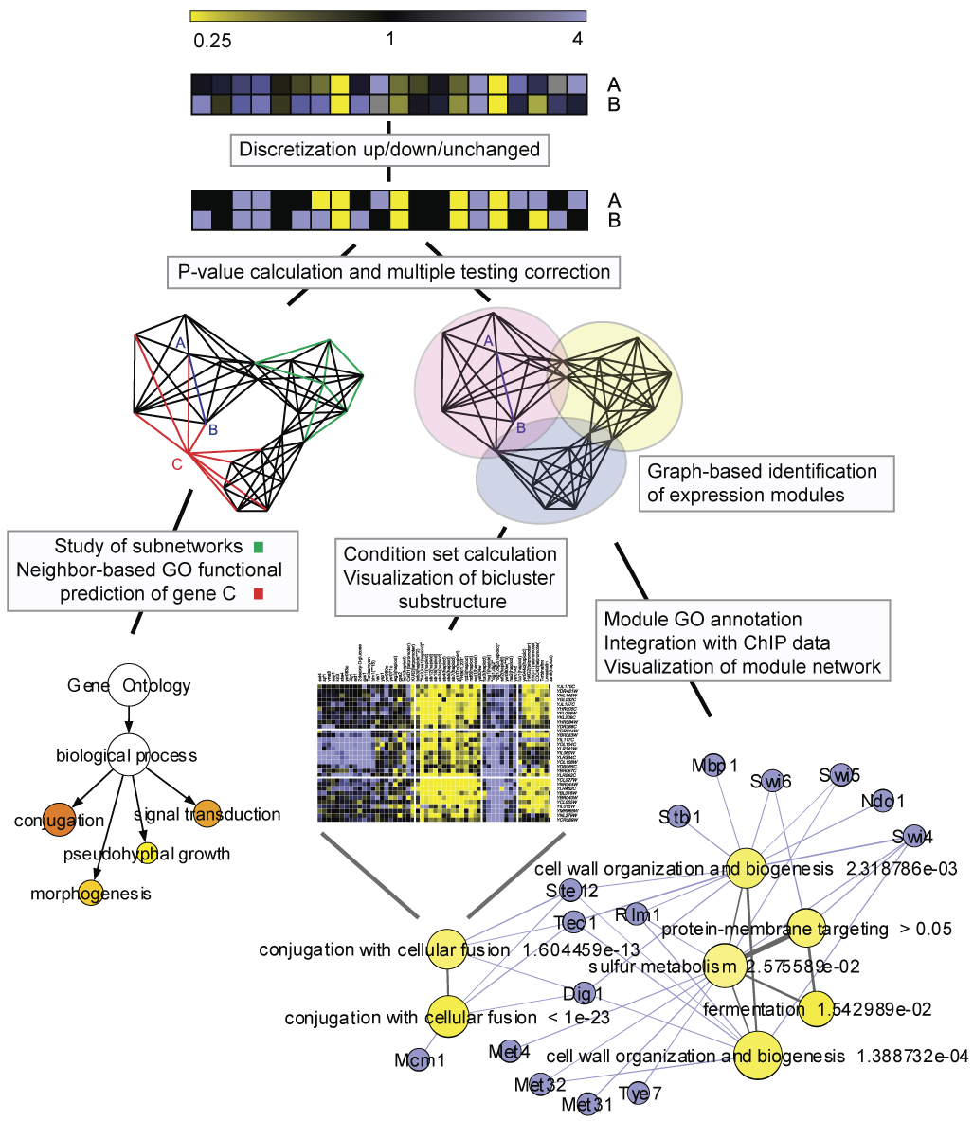
Figure 2.

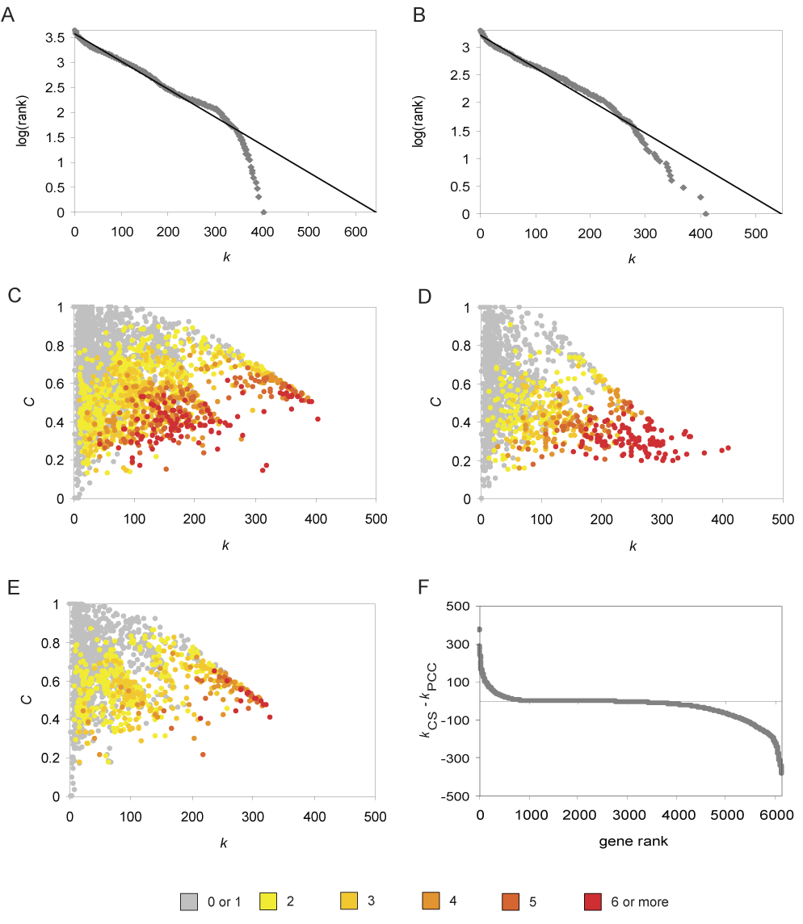
Figure 3.

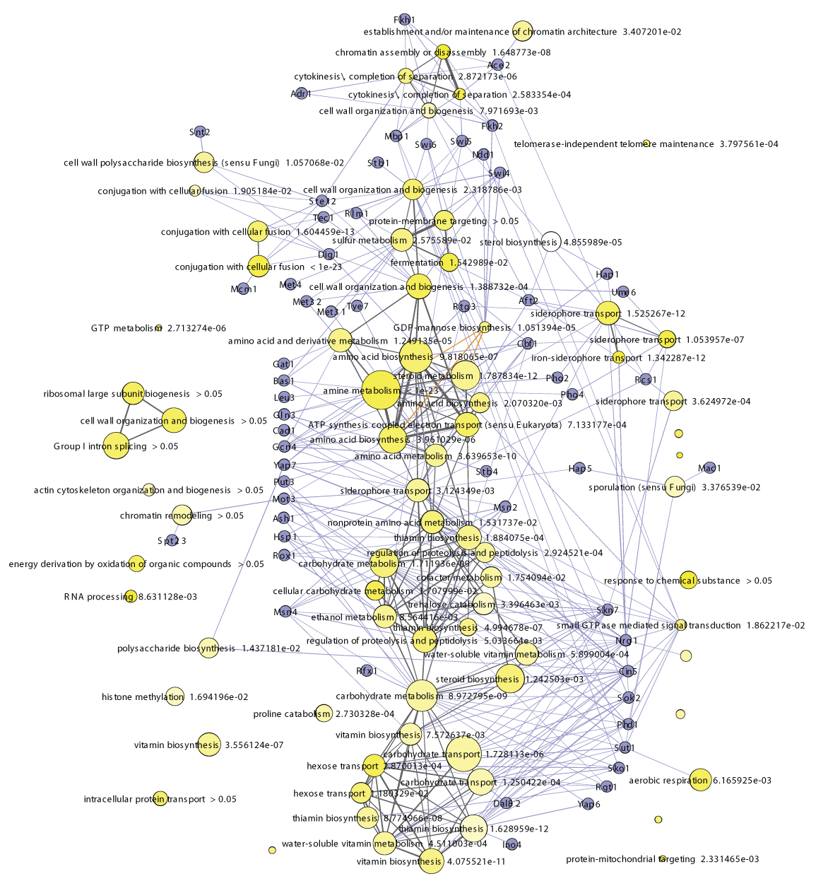
Figure 4.

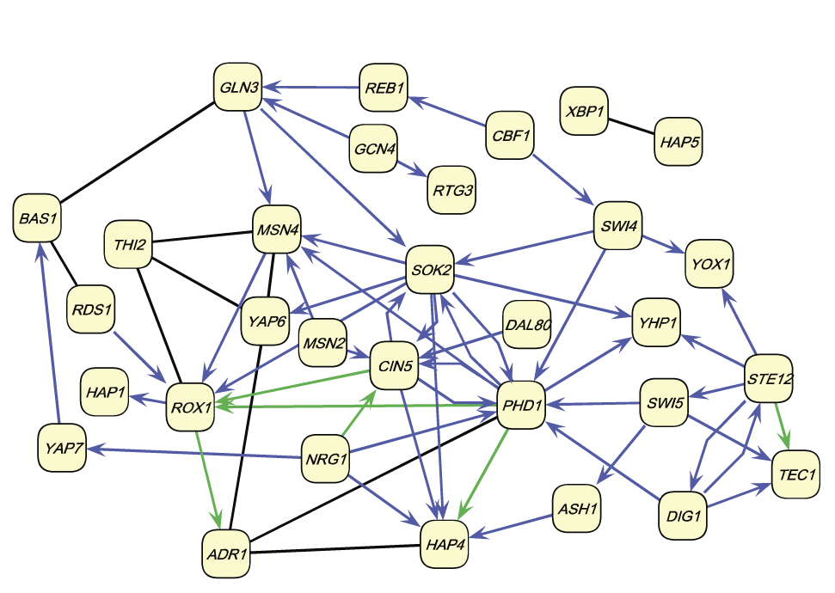
Figure 5.

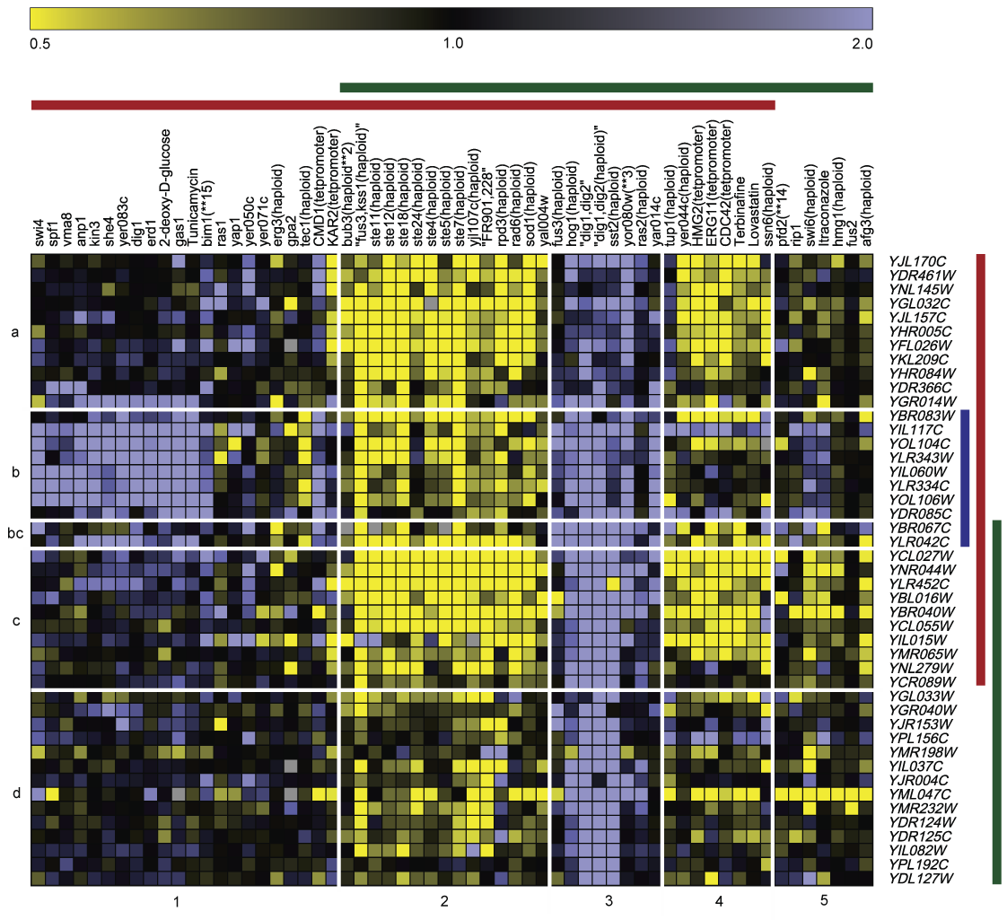
Figure 6.

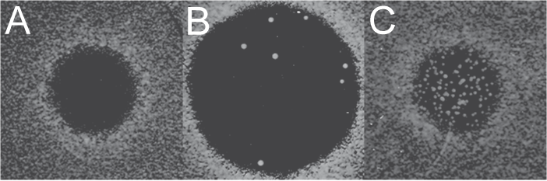
Tables

Table I. Overrepresented GO Slim categories among hubs in the CS and PCC networks profiled against all genes in the network or on the microarray. The numbers are FDR corrected P-values.

GO category | GO description | CS hubs against |  | PCC hubs against
 |  | chip | network | chip | network
GO:0008372 | cellular component unknown | 7.22E-12 | 1.17E-02 | - | -
GO:0005618 | cell wall | 7.22E-12 | 6.07E-03 | 4.13E-02 | -
GO:0006766 | vitamin metabolism | 5.95E-08 | 6.07E-03 | - | -
GO:0016491 | oxidoreductase activity | 1.06E-05 | - | - | -
GO:0005886 | plasma membrane | 4.99E-05 | - | - | -
GO:0005215 | transporter activity | 6.13E-04 | - | - | -
GO:0005975 | carbohydrate metabolism | 7.12E-04 | - | 6.21E-04 | 1.70E-03
GO:0005576 | extracellular region | 8.98E-04 | - | - | -
GO:0000004 | biological process unknown | 2.32E-03 | - | - | -
GO:0006519 | amino acid and derivative metabolism | 6.44E-03 | - | - | -
GO:0007047 | cell wall organization and biogenesis | 1.84E-02 | - | - | -
GO:0000746 | conjugation | 3.01E-02 | - | - | -
GO:0005840 | ribosome | - | - | 4.20E-21 | 5.19E-15
GO:0042254 | ribosome biogenesis and assembly | - | - | 2.54E-17 | 4.56E-13
GO:0005198 | structural molecule activity | - | - | 1.09E-13 | 4.34E-10
GO:0005730 | nucleolus | - | - | 6.42E-13 | 3.50E-09
GO:0006416 | protein biosynthesis | - | - | 4.49E-11 | 1.73E-07
GO:0016070 | RNA metabolism | - | - | 6.21E-04 | 2.06E-03
GO:0003723 | RNA binding | - | - | 8.17E-04 | 1.43E-03
GO:0006091 | generation of precursor metabolites and energy | - | - | 1.33E-03 | 2.24E-02
GO:0005737 | cytoplasm | - | - | 1.85E-02 | -

Table II. Top-25 hubs in the CS network. The second column contains the number of modules that the hub is assigned to, the third column contains the positive degree of the hub in the CS network, and the fourth column its clustering coefficient.

ORF | # modules | k | C | CYGD description
YDL244W | 20 | 327 | 0.213242 | strong similarity to THI5P, YJR156c, YNL332w and  A. parasiticus, S.pombe NMT1 protein
YPR015C | 16 | 370 | 0.23983 | similarity to transcription factors
YPL222W | 14 | 318 | 0.200107 | similarity to C.perfringens hypothetical protein
YJR156C | 14 | 303 | 0.199987 | thiamine regulated gene, homologous to nmt1a in S. pombe
YPR078C | 13 | 322 | 0.243532 | hypothetical protein
YIR039C | 13 | 307 | 0.228928 | GPI-anchored aspartic protease (Yapsin 6)
YBR072W | 13 | 273 | 0.250081 | heat shock protein
YMR251W | 13 | 236 | 0.22207 | strong similarity to YKR076w and YGR154c
YNR058W | 12 | 411 | 0.263474 | DAPA aminotransferase
YBR297W | 12 | 401 | 0.247007 | maltose fermentation regulatory protein
YJR159W | 12 | 342 | 0.230471 | sorbitol dehydrogenase
YPL282C | 12 | 303 | 0.293839 | strong similarity to subtelomeric encoded proteins
YKL035W | 12 | 280 | 0.227215 | UTP--glucose-1-phosphate uridylyltransferase
YKR076W | 12 | 251 | 0.246566 | involved in cell wall biogenesis and architecture
YBR054W | 12 | 250 | 0.22143 | strong similarity to HSP30 heat shock protein Yro1p
YHR071W | 11 | 346 | 0.321253 | cyclin like protein interacting with PHO85P
YGR032W | 11 | 298 | 0.274399 | 1,3-beta-D-glucan synthase subunit
YPL054W | 11 | 291 | 0.275791 | similarity to S. pombe scp3/SPAC3A11.02 spindle poison  sensitivity related protein
YBR147W | 11 | 287 | 0.363953 | strong similarity to hypothetical protein YOL092w
YGR043C | 11 | 282 | 0.299967 | strong similarity to transaldolase
YEL060C | 11 | 272 | 0.260473 | protease B, vacuolar
YPL223C | 11 | 266 | 0.19773 | induced by osmotic stress
YMR008C | 11 | 263 | 0.318056 | phospholipase B (lysophospholipase)
YBR066C | 11 | 251 | 0.324016 | weak similarity to A.niger carbon catabolite repressor protein
YLR149C | 11 | 246 | 0.291156 | weak similarity to hypothetical protein SPCC4G3.03 S. pombe

Table III. The number of genes predicted to be involved in mating based on coexpression or antiexpression with mating genes. The ‘GO’ and ‘Literature’ columns contain the number of candidate genes that are known to be involved in mating based on GO information and literature, respectively. Between parentheses is the number of genes for which mating was the best prediction.

Prediction  based on | Method | Candidate genes
 |  | GO | Literature | Novel | Total
Coexpression | CS/PCC | 14 (14/12)¹ | 6 (6/4) | 10 (9/6) | 30 (29/22) ¹
 | CS only | 8 (5) | 2 (2) | 28 (17) | 38 (24)
 | PCC only | 2 (1) | 3 (2) | 12 (5) | 17(8)
 | Sum | 24 (20) | 11 (10) | 50 (31) | 85 (61)
Antiexpression | CS/PCC | 0 | 0 | 0 | 0
 | CS only | 1 (1) | 0 | 6 (6) | 7 (7)
 | PCC only | 0 | 0 | 4 (2) | 4 (2)
 | Sum | 1 (1) | 0 | 10 (8) | 11 (9)
Total |  | 25 (21) | 11 (10) | 60 (39) | 96 (70)
¹ Numbers between parentheses correspond to CS and PCC predictions, respectively.

Table IV. Overview of mating predictions. There are 71 genes, unknown to be involved in mating according to their GO annotation, that have a significant association with mating-related genes in the CS and/or PCC networks. Genes for which a potential link to mating could be deduced from their description or GO annotation are marked yellow in the status column (bright yellow: very likely, contain mating-related term in their description or are annotated to mating-related GO term other than ‘conjugation’ (GO:0000746) or a subcategory thereof; soft yellow: potentially involved in mating). U denotes genes annotated to the ‘biological process unknown’ category, N/A denotes genes for which there is no annotation available. The other genes are annotated to non-mating GO terms. Genes that belong to either of the mating clusters depicted on Figure 5 have a green field in the cluster column. Genes that were assigned to a mating-related cluster in Tanay et al (2004) are indicated by a capital ‘T’ in the cluster column. Genes that show coexpression with mating genes have a plus sign in the ‘c/a’ column, genes that show antiexpression are similarly labeled with a minus sign and highlighted in red. For every gene, the P columns contain the lowest of all mating-related P-values, i.e. P-values for GO categories below ‘conjugation’ (GO:0000746). An orange field in the CS or PCC ‘best hit’ column indicates that conjugation or a child category is the best functional prediction for that gene in the given network. The last column indicates whether the promoter of a gene contains binding sites for Ste12, Dig1, Tec1 or Mcm1 (data from Harbison et al (2004), sites bound with P < 0.005 and with motif conserved in at least one other Saccharomyces sp.). Binding sites downstream of the gene are indicated with (3’). Genes for which no binding site information was available are indicated with N/A.

 |  |  |  | CS |  | PCC |  |  |  |  |  |  | CS |  | PCC
ORF | Status | Cluster | c/a | P | Best hit | P | Best hit | Binding  sites | ORF | Status | Cluster | c/a | P | Best hit | P | Best hit | Binding  sites
YNL279W |  | T | + | 1.00E-23 |  | 1.14E-07 |  | Dig1, Ste12 | YLR364W | U |  | + | 3.28E-04
YKL209C |  | T | + | 7.94E-21 |  | 1.69E-14 |  | Dig1, Ste12,  Mcm1 | YLR338W | N/A |  | - | 7.46E-04 |  |  |  | N/A
YLR042C | U | T | + | 6.10E-19 |  | 3.11E-07 |  |  | YMR316C-B | N/A |  | - | 8.21E-04 |  |  |  | N/A
YGR014W |  | T | + | 7.95E-19 |  |  |  | Dig1, Ste12,  Tec1 | YKR013W | U | T | + | 1.67E-03 |  |  |  | Dig1, Ste12
YIL015W |  | T | + | 3.32E-18 |  |  |  | Dig1, Ste12 | YIL057C | U |  | - | 1.84E-03
YLR334C | N/A | T | + | 2.42E-16 |  |  |  | N/A | YPR077C | N/A |  | + | 2.21E-03 |  |  |  | N/A
YBR083W |  | T | + | 1.26E-15 |  | 5.46E-15 |  | Dig1, Ste12,  Tec1 | YGR126W | U |  | + | 2.58E-03
YIL082W | N/A | T | + | 1.39E-15 |  | 2.32E-06 |  |  | YKL104C |  | T | + | 2.67E-03 |  | 3.06E-03 |  | Dig1, Ste12,  Tec1
YOL104C |  | T | + | 1.24E-13 |  | 1.93E-08 |  | Dig1, Ste12,  Tec1 (3') | YKL043W |  |  | + | 2.93E-03 |  |  |  | Dig1
YBR067C |  | T | + | 5.15E-13 |  |  |  | Ste12 (3') | YGR161C |  |  | - | 3.97E-03
YMR232W |  | T | + | 1.13E-12 |  | 7.32E-05 |  | Dig1, Ste12,  Tec1 | YMR196W | U |  | + | 4.86E-03
YDR124W | U | T | + | 1.22E-12 |  | 6.10E-04 |  |  | YPR191W |  |  | + | 4.96E-03
YPL192C |  | T | + | 8.20E-12 |  | 9.21E-04 |  | Dig1, Ste12 | YMR304C-A | N/A | T | + | 5.14E-03 |  |  |  | N/A
YDR366C | U | T | + | 1.21E-10 |  |  |  | N/A | YKL148C |  |  | + | 6.42E-03
YGR040W |  |  | + | 1.36E-10 |  | 3.92E-04 |  | Mcm1 (3') | YJR149W | U |  | + | 8.96E-03
YGL262W | U |  | - | 2.85E-10 |  |  |  |  | YER187W | U | T | + | 9.01E-03 |  |  |  | Dig1, Ste12  (3')
YJR153W |  | T | + | 1.78E-09 |  | 8.28E-05 |  |  | YKL189W |  | T | + |  |  | 9.78E-06 |  | Dig1, Ste12
YIL060W | U | T | + | 1.94E-09 |  |  |  | N/A | YGR122C-A | N/A |  | + |  |  | 3.96E-04 |  | N/A
YDR125C |  | T | + | 2.57E-09 |  |  |  |  | YIL135C |  |  | + |  |  | 6.31E-04
YOL106W | N/A | T | + | 4.17E-09 |  |  |  | N/A | YBL052C |  |  | + |  |  | 9.78E-04
YLR307W |  | T | + | 1.22E-08 |  |  |  |  | YDR520C | U |  | - |  |  | 1.55E-03
YFL027C |  | T | + | 7.43E-08 |  | 1.07E-05 |  | Dig1, Ste12,  Mcm1 | YDL095W |  |  | + |  |  | 1.91E-03
YLR343W | U |  | + | 1.78E-07 |  |  |  |  | YER023W |  |  | + |  |  | 2.09E-03
YJL078C | U |  | - | 3.51E-07 |  |  |  |  | YMR126C | U |  | - |  |  | 2.11E-03
YMR198W |  | T | + | 3.76E-07 |  |  |  | Dig1, Ste12 | YMR158C-B | N/A |  | + |  |  | 2.83E-03 |  | N/A
YGL033W |  | T | + | 5.85E-07 |  | 3.53E-03 |  |  | YKL127W |  |  | + |  |  | 3.22E-03 |  | Tec1
YDR309C |  | T | + | 2.62E-06 |  | 4.19E-03 |  | Dig1, Ste12,  Tec1 | YKR091W |  |  | + |  |  | 3.67E-03 |  | Dig1, Ste12,  Tec1
YDL127W |  | T | + | 7.14E-06 |  |  |  | Dig1, Ste12,  Tec1 | YPL127C |  |  | + |  |  | 6.25E-03
YGL205W |  |  | + | 1.56E-05 |  |  |  |  | YBR078W |  |  | + |  |  | 6.49E-03 |  | Ste12
YHR152W |  | T | + | 5.95E-05 |  |  |  | Ste12, Mcm1 | YLR332W |  | T | + |  |  | 7.37E-03 |  | Dig1, Ste12
YFL012W | U |  | + | 7.33E-05 |  |  |  |  | YKR029C |  |  | - |  |  | 8.36E-03
YNL042W |  | T | + | 1.01E-04 |  | 4.92E-05 |  |  | YMR001C |  |  | + |  |  | 8.42E-03 |  | Mcm1
YGL230C | U |  | + | 1.49E-04 |  |  |  |  | YER090W |  |  | - |  |  | 8.52E-03
YIL168W | N/A |  | + | 1.51E-04 |  |  |  | N/A | YPL163C |  |  | + |  |  | 8.69E-03 |  | Dig1, Ste12,  Tec1
YOR214C | U |  | + | 1.81E-04 |  |  |  |  | YAL023C |  |  | + |  |  | 8.75E-03
YNL332W |  |  | + | 3.11E-04

