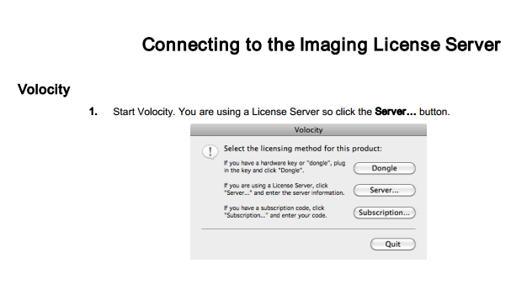

Select ‘Server’

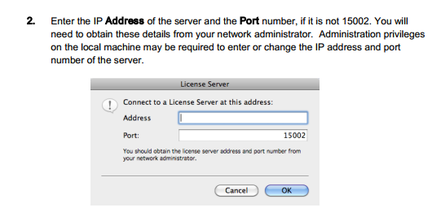

Address is : 192.168.50.32

Port is: 15002

***NOTE:***

***If this is the first time you use the Volocity after installation, you could get a window ‘User Account Control’, asking you to give an administrator password. Clicking one or several times NO, allows you to skip this step.***

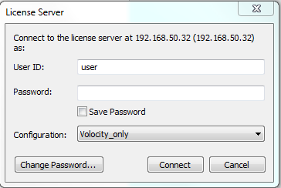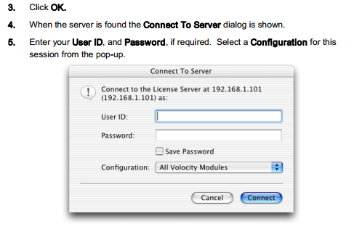

User ID is: user

No password

Configuration: Select:

- ‘Volocity_only’ (default, standard use like looking images, exporting, putting scale, …

- ‘Volocity-all packages’ Only if you need special analysis as only 5 licenses for Volocity_all packages

