

We hereby cordially invite you to the following

**SEMINAR**

**New frontiers in RNA metabolism:**

**the biology of RNA-kinases and -ligases**

By Prof. Javier Martinez,

IMBA, Vienna, AT

[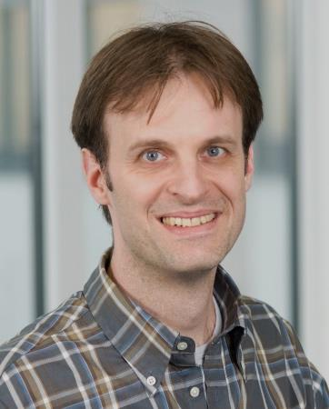](http://www.google.be/url?sa=i&source=images&cd=&cad=rja&docid=_h9o3-KlrD3ZWM&tbnid=4ze_9l5II8QgTM:&ved=0CAgQjRwwAA&url=http://www.imba.oeaw.ac.at/news-media/news/news/mutated-gene-causes-nerve-cell-death/&ei=R-06Uvi7IuOb0QX7yoDADw&psig=AFQjCNEQAl6v6UcKSnB0T7M_0nhr-f6pEw&ust=1379679943624289)

**Thursday, November 28th, 2013**

**15h00**

Schell Seminar room

UGent-VIB Research building FSVM

Technology Park 927 – B-9052 Zwijnaarde

Host: Jo Bury

Selected papers:

[Hanada T](http://www.ncbi.nlm.nih.gov/pubmed?term=Hanada%20T%5BAuthor%5D&cauthor=true&cauthor_uid=23474986) et al. CLP1 links tRNA metabolism to progressive motor-neuron loss.

*Nature* 2013, 495(7442):474-80.

[Popow J](http://www.ncbi.nlm.nih.gov/pubmed?term=Popow%20J%5BAuthor%5D&cauthor=true&cauthor_uid=21311021) et al. HSPC117 is the essential subunit of a human tRNA splicing ligase complex.

*Science* 2011, 331(6018):760-4.

Weitzer S, Martinez, J

The human RNA kinase hClp1 is active on 3' transfer RNA exons and short interfering RNAs.

*Nature* 2007, 447(7141): 222-6.