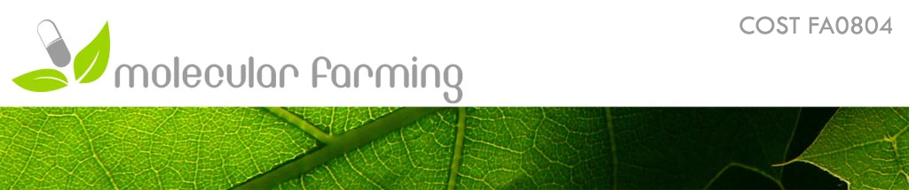**Program**

**COST meeting FA804**

**14 – 16 September 2011, Gent, Belgium**

**Wednesday, 14 September 2011 (FSVM building, VIB)**

14.00 – 15.00 Registration – coffee

15.00 – 15.30 Ann Depicker (VIB, UGent): Welcome

15.30 – 16.00 **Alain Goossens (VIB, UGent, Belgium) : Production of novel bioactive molecules by combinatorial biosynthesis in plant cells**

16.00 – 16.30 **Wout Boerjan (VIB, UGent, Belgium) : Bio-energy from poplar**

16.30 – 17.30 Guided tour in the Schell/Fiers/VanMontagu VIB building

Coffee

17.30 – 18.00 Marc De Loose (ILVO, Belgium) : Coexistence field trial

18.00 – 18.30 Bart Van Droogenbroeck (ILVO, Belgium) : Field trial with transgenic potatoes

18.30 – 19.30 Walk to “Kasteel van Zwijnaarde”

19.30 – 22.30 Reception and Welcome Dinner in “Kasteel van Zwijnaarde”

**Thursday, 15 September 2011 (Hotel Monasterium)**

08.30 – 09.00 Registration

09.00 – 09.15 Introduction: Ann Depicker and Kirsi-Marja Oksman

**09.15 – 10.00 Nico Callewaert (VIB, UGent, Belgium): Which glycans in which expression system for which therapeutic application?**

10.00 – 10.15 Herta Steinkellner (Vienna, Austria): Plant glycoengineering: an advantage over mammalian cell based systems?

10.15 – 10.30 Bieke Nagels (UGent, Belgium): Production of human erythropoietin with multi-antennary N-glycan structures in Nicotiana benthamiana plants

10.30 – 10.45 Alexandra Castilho (Vienna, Austria): In planta sialylation of recombinant proteins

10.45 – 11.15 Coffee break and poster viewing

**11.15 – 12.00 Peter Casteels (Ablynx, Belgium): Manufacture of Nanobodies: from Pipeline into the Clinic**

12.00 – 12.15 Sylvie De Buck (VIB, UGent, Belgium): Production of VHH and VHH-Fc antibodies in *Arabidopsis thaliana* seeds

12.15 – 12.30 Vikram Virdi (VIB, UGent, Belgium): Passive immunization of piglets against post weaning diarrhoea via anti-ETEC antibodies produced in seeds

12.30 – 13.45 Lunch in Monasterium hotel

13.45 – 14.45 Guided STSM poster tour

14.45 – 15.30 **Anni Van Broeckhoven (Crea Bio Support, Ghent, Belgium): GMP Processing and purification of recombinant proteins**

15.30 – 15.45 Geert Angenon (VUB, Belgium): Production in plant seeds of an oral veterinary vaccine against avian influenza

15.45 – 16.05 **Siva Reddi (New Delhi, India):** **Tobacco chloroplast transformation for over production of antibodies and cellulolytic enzymes**

16.05 – 16.30 Coffee break and poster viewing

16.30 – 16.45 Kristiina Makinen (Helsinki, Finland): Methods to enhance protein expression from Potato virus A gene vector in plants

16.45 – 17.00 George Lomonosoff (Norwich, UK): Production of virus-like particles for therapeutic applications

17.00 – 17.15 Anders Kvarnheden (Upsala, Sweden): Begomovirus-associated DNA-satellites and their potential as expression vectors in plants

17.15 – 17.30Catherine Navarre (UCLouvain, Belgium): Expression of different antibody isotypes in suspension cell cultures

17.30- 17.45 Henrik Brinch-Pedersen (Slagelse, Denmark): A cereal platform for the

production of phytases

17.45- 18.00 Udo Conrad (Gatersleben): Production of very large spider silk proteins by posttranslational fusions *in vivo*.

18.30 – 20.00 Guided tour in Gent

20.00 Dinner

**Friday, 16 September 2011 (Hotel Monasterium)**

**09.00 – 09.45 Jan Desomer (Bayer BioScience N.V., Belgium): From "green juice" to "galactosylated plantibodies": IP landscape of molecular farming**

09.45 – 10.00 Harry Thangaraj (United Kingdom): Intellectual Property and molecular farming

10.00 – 10.15 Stefan Schillberg (Aachen, Germany): Recent progress of the EU FP7 CoMoFarm project

10.15 – 10.30 Dirk Bosch: Molecular farming database feedback and update on target products (WP3)

10. 30 – 10.45 Julian Ma: Headlines from the plant produced vaccines and antibody meeting in Porto June 2011

10.45 – 11.15 Coffee break and poster viewing

**11.15 – 12.00 Marc Zabeau (Tech Transfer, UGent): Tech transfer from academics**

12.00 – 12.15 Stefan Schilberg and Einar Mantyla: update on WP2 -plant production platforms and downstream processing

12.15 – 12.30 Paul Christou and Bart van Droogenbroeck: Update on WP1 -the social economic position of molecular farming

12.30 – 13.00 Discussion – chaired by the WP leaders

Concluding remarks: Julian Ma and Kirsi-Marja Oksman

13.00 - Lunch in Monasterium hotel

14.00 – 17.00 **Management committee meeting chaired by Kirsi-Marja Oksman**